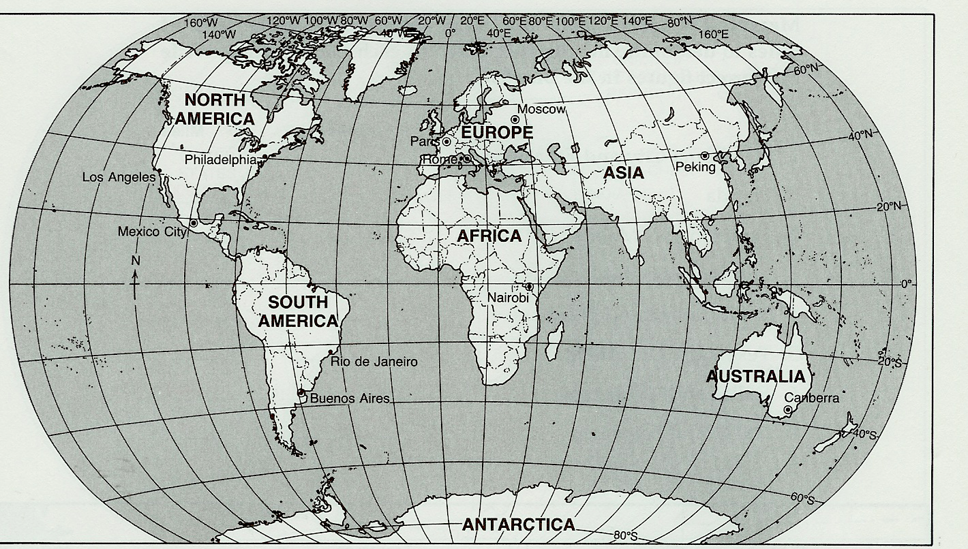
World War II: Test Review
Pacific Ocean (Asia):
Pacific Ocean (N. America):
Western Front (Western Europe):
Eastern Front (Eastern Europe):
North African Campaign:
Directions: Label: which battles happened in which theatre of war, when, and who won each. You must know all of them for the test.

Battles: D-Day, Stalingrad, Battle of the Bulge, El Alamein, Atlantic, Iwo Jima, Okinawa, Pearl Harbor, Coral Sea, Operation Barbarossa, Dunkirk, Kursk, Battle of Britain, Occupation of France, Invasion of Poland, Hiroshima & Nagasaki

Hitler
Stalin
Churchill
Mussolini
Franco
Hirohito
Tojo
Rommel
De Gaulle
Poland
US entry
Fascism
Germany invaded (which countries)
Eastern Front battles
Blitzkrieg (what? Tactics?)
Persecuted by Nazis
Japanese Internment
Supreme Commander of Allied Forces, Pacific
Supreme Commander of Allied Forces, Atlantic
D-Day
Atomic Bomb
- Plane?
- Who’s decision?
- Why?
Battle of Britain (+names of air force participants)
European nations that stopped Germany
Neutral countries
Turning Points (Europe – West, East; Pacific)
Major Allied Powers
Major Axis Powers
Neutral Powers in Europe
Part of France not occupied by Germans
Allied strategy (defeat who then who?)
Luftwaffe
Royal Air Force
Vichy France
Death of FDR
Death of Hitler
Death of Mussolini
Tuskegee Airmen
Bataan Death March
Changes in US post-WWII
Who won?

