Understanding Color Activity – Day 1

Lesson 1: Value
In a new MS Publisher document, insert a textbox and type into it the first letter of your first name. Change the font to something that represents you, and increase the font size to at least 48 points.

Step 1: Use value to create movement.

Step 2: Use value to lead the eye.

Step 3: Use one color to change the effect of value.

Lesson 2: Color Talk

Step 1: Find a picture based on analogous colors. Make a color pallette that proportionally represents your color reference.

Step 2: Find a picture based on complementary colors. Make a color pallette that proportionally represents your color reference.

Use this website for help: http://www.jellocube.com/screendesign/harmonies.swf

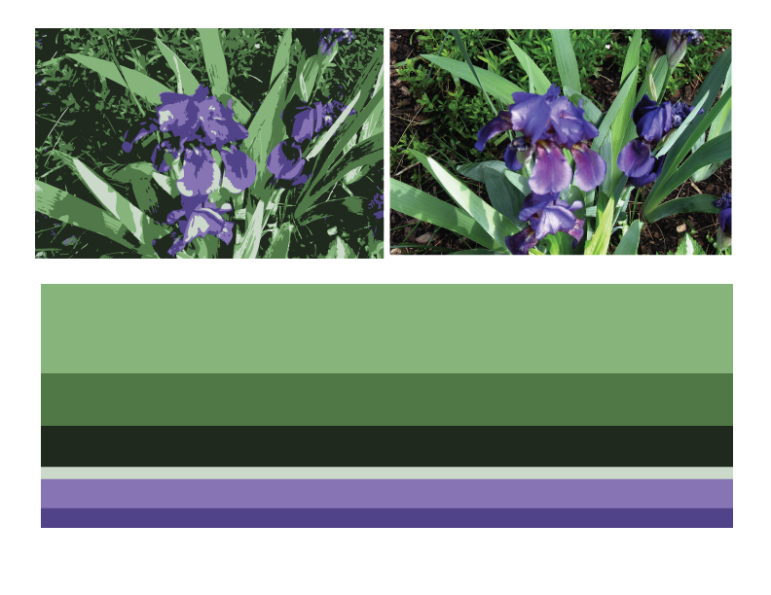

Picture

Pallette

Lesson 3: Hues, tints, shades, & saturation

Pick your favorite color. Make a shape on your document and fill it with that color. Label that shape “hue: ____________.” Then, copy and paste four more of the shape. Change the saturation to show the two examples of tint, and two examples of shade. Label each shape with either “shade” or “tint.”

