The Court System – Review, Games, Reflection

Part I: Review
The Courts in a Nutshell (https://www.icivics.org/web-quests/courts-nutshell) - link on weebly

- According to the Constitution, who has the power to create federal courts that are below the Supreme Court?

- List one type of case that federal courts have jurisdiction over, one type that state courts have jurisdiction over, and one type that BOTH court systems can hear.
  - Federal: ________________________
  - State: _________________________
  - Both: __________________________

- For each problem, mark which system of courts has jurisdiction.
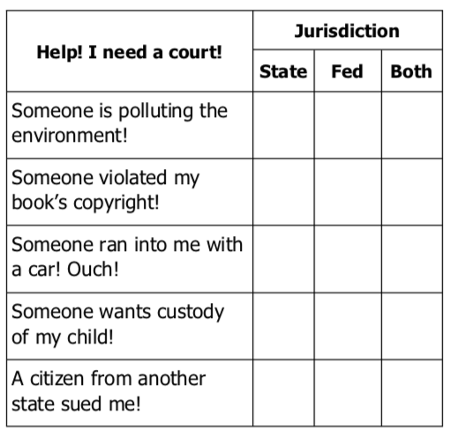
- Look at the list of courts in your state. Decide which one is the highest court and click the link to that court’s website. On the site, look for a description of the court or the judges.
  - Name of my state’s highest court: _______________________________________
  - Number of judges on that court: ________________________________________

- How are the districts inside a state named?
  - Is your state divided into districts? Yes No
  - Complete this sentence:
    - I live in the ______________________________
    - District of _______________________________.
- Federal Court of Appeals: Which circuit do you live in?

- The Highest Court in the Land is the:
  - Who is the current Chief Justice?
  - Who has been on the court the longest?
  - What year did that justice take his/her seat?

- Complete the following information for three Supreme Court justices. Assume they sat on the Court of Appeals until the year they were appointed to the Supreme Court.
Justice _____________________ served on the _____ Circuit Court of Appeals for _____ years.
Justice _____________________ served on the _____ Circuit Court of Appeals for _____ years.
Justice _____________________ served on the _____ Circuit Court of Appeals for _____ years.

- Did any of the justices serve on the Court of Appeals in YOUR circuit?
No. I’m in the ________________________ circuit, and none served there.
Yes. Justice _________________________ served in the _____ circuit.

Part II: Games
Game 1: Court Quest (see link on weebly for game)

After playing the game, answer the following questions:
- How would you describe the difference between the federal and state court systems?

- Some states have very specialized courts. Which ones do you remember from the game?

- What would happen if there was no appellate process?

Game 2: Argument Wars (see link on weebly for game)

After playing the game, answer the following questions:
- When did arguments fail in the game? Why do you think they failed?

- What made an argument successful? Why do you think that made the argument successful?

- What is necessary to win a case at the Supreme Court?

