Checklist 1: Organization

Introduction:

Yes No
______ ______ Does my introduction proceed clearly from the opening to the thesis?

In your introduction,
- Establish the issue (background)
- Include a time frame reference
- Provide some context (not to be repeated in a later argument)
- Conclude with your approved thesis statement.

Arguments:

Yes No
______ ______ Does all information in my paper consistently relate to my thesis?
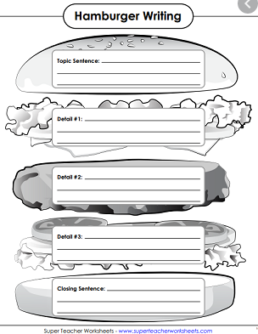
______ ______ Does each body paragraph have a clear main idea that relates to the thesis? Each argument should start with a clear topic sentence that relates directly to your thesis.

______ ______ Do all the details in the paragraph relate to the main idea?

______ ______ Do the main ideas in the body paragraphs flow in a logical order? Each point builds on the previous point (rather than circling back or repeating).

______ ______ Is each paragraph connected to the one before it?

______ ______ Is all information in its proper place in my paper? For example, I have nothing in one argument that would be better served in my introduction or conclusion, or in another argument.

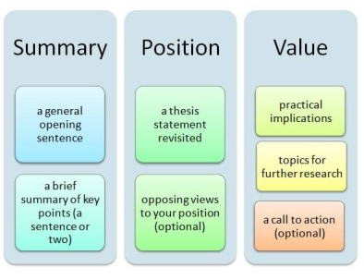
Conclusion:

Yes No
______ ______ Does my conclusion add value?

One or more of the following strategies may help you write an effective conclusion:
- Synthesis: Connect your research to other research
- So what: Why is anything of this important? What might future research bring?
- Point to broader implications. For example, if your paper examines the Greensboro sit-ins or another event in the Civil Rights Movement, you could point out its impact on the Civil Rights Movement as a whole.

Do not:
- Begin with an unnecessary, overused phrase such as “in conclusion,” “in summary,” or “in closing.” Although these phrases can work in speeches, they come across as wooden and trite in writing.
- Restate your thesis.
- Introduce a new idea or subtopic in your conclusion.
- Include any information you’ve already included in your paper
- Summarize your paper
- Make sentimental, emotional appeals that are out of character with the rest of an analytical paper.
- Include evidence (quotations, statistics, etc.) that should be in the body of the paper.

Checklist 2: Cohesion

Yes No
______ ______ Does the opening of the paper clearly connect to the broader topic and thesis? Make sure quotes or anecdotes serve a purpose.

______ ______ Are my claims clear? Are they supported with many, strong examples?

______ ______ Have I included support from research for each main point in my paper?

______ ______ Have I included introductory material before any quotations? Quotations should never stand alone in a paragraph.

______ ______ Does paraphrased and quoted material clearly serve to develop my own points?

______ ______ Are there any places where I have overused material from sources? Avoid multiple consecutive citations from the same source. This makes your paper a report, or series of reports, on someone else’s work.

______ ______ Does my conclusion make sense based on the rest of the paper? Make sure any new questions or suggestions in the conclusion are clearly linked to earlier material.

Checklist 3: Style

Yes No
______ ______ My paper avoids excessive wordiness and redundancy.

______ ______ My sentences are varied in length and structure.

______ ______ I have avoided using first-person pronouns such as I and we and second-person pronouns such as you and your.

______ ______ I have used the active voice whenever possible.

______ ______ I have defined specialized terms that might be unfamiliar to readers.

______ ______ I have used clear, straightforward language whenever possible and avoided unnecessary jargon.

______ ______ I have avoided editorializing – showing my opinion usually through the use of unnecessary adjectives.

Checklist 4: Grammar, Mechanics, Punctuation, Usage, and Spelling

Yes No
______ ______ My paper is free of grammatical errors, such as errors in subject-verb agreement and sentence fragments.

______ ______ My paper is free of errors in punctuation and mechanics, such as misplaced commas or incorrectly formatted source titles.

______ ______ My paper is free of common usage errors, such as alot and alright.

______ ______ My paper is free of spelling errors. I have proofread my paper for spelling in addition to using the spell-checking feature in my word-processing program.

______ ______ I have checked my paper for any editing errors that I know I tend to make frequently.

Checklist 5: Citations and Formatting

Yes No
______ ______ Within the body of my paper, each fact or idea taken from a source is credited to the correct source.

______ ______ MLA: Each in-text citation includes the source author’s last name (or, where applicable, the organization name or source title) and page number if applicable. I have used the correct format of in-text and parenthetical citations.

______ ______ APA: Each in-text citation includes the source author’s last name and year of publication.

______ ______ Chicago: Each footnote includes the proper Turabian style citation that differs from the bibliographic citation at the paper’s end.

______ ______ Each source cited in the body of my paper has a corresponding entry in the works cited (MLA), references (APA), or bibliography (Chicago) of my paper.

______ ______ My works cited (MLA), references (APA), or bibliography (Chicago) section includes the proper heading and double-spaced, alphabetized entries.

______ ______ Each entry in my works cited (MLA), references (APA), or bibliography (Chicago) section is indented on the second line and all subsequent lines.

______ ______ Each entry in my works cited (MLA), references (APA), or bibliography (Chicago) section includes all the necessary information for that source type, in the correct sequence and format.

______ ______ My paper includes a title page.

______ ______ My paper includes a page numbers with my last name before each page number.

______ ______ The margins of my paper are set at one inch. Text is double spaced with no extra spaces between paragraphs and set in a standard 12-point font.

Checklist 6: Final Review

Yes No
______ ______ All information presented relates specifically to my thesis.

______ ______I have reviewed the rubric (see attached) and feel confident in all areas.

______ ______My formatting is correct based on the requirements listed on the rubric.

______ ______I have at least 5,000 words, excluding my title page and references list.

______ ______ I have at minimum 15 scholarly sources cited correctly.

______ ______ I have read my paper out loud to myself.

______ ______ Someone else has read my paper thoroughly and given me feedback.

______ ______I have run my paper through Turnitin using the draft forum on Canvas. I know my unoriginality score MUST be under 30 percent, and I may not have any instances of seven or more consecutive, unoriginal words to be considered free from plagiarism.

