US History
Robber Barons or Captains of Industry?

Directions: Complete research online about each of the following entrepreneurs. Seek to discover not only information about the background of each, but also what kind of businessmen they were. Consider many concepts here, including how many people they provided jobs for, how they treated their employees, how charitable they were, etc. Once you have at least 3 to 5 contributing factors for each, make an individual determination about whether or not each individual should be considered a Captain of Industry or a Robber Baron.

 | Important biographical information (born rich? Education? Immigrant? How’d he get where he did?) | Captain of Industry? (contributing factors to why he was a good, moral businessman) | Robber Baron?  (contributing factors to why he was a corrupt businessman) | Verdict (Captain of Industry or Robber Baron)
Andrew Carnegie

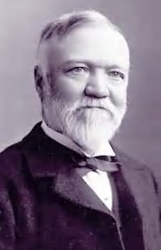

Cornelius Vanderbilt

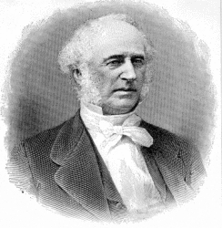

J.P. Morgan

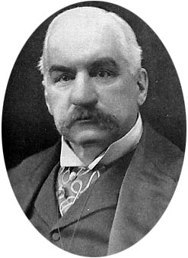

John D. Rockefeller

