US History: Road to Revolution Activity

Historical Question: How did the colonists feel as a result of British actions after the French & Indian War?

Use each of the following terms at least once within the chart to answer the question. You don’t have to provide a formal definition, but show your knowledge by using each in a sentence properly.

Proclamation of 1763
Sugar Act
Townshend Acts
Tea Act
Coercive (aka Intolerable) Acts
Currency Act
Quebec Act
Boston Massacre
Boston Tea Party
First Continental Congress
Second Continental Congress
Lexington and Concord
Patriots
Tories

Some of the colonists felt… | When…
Frustrated

Joy

Disregarded

Anticipation

Fear

Some of the colonists felt… | When…
Surprise

Add one more (your choice)

Paul Revere’s “The Boston Massacre”

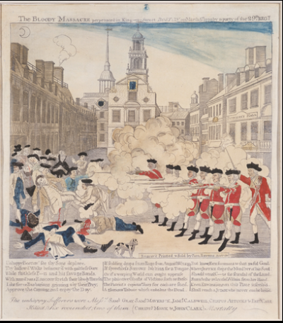

Based on the print…

What seems to be important to Paul Revere, the person who created this?

What does he want us to know?

What’s something he chose to do in this work?

What’s interesting or effective about his choices?

How does Revere present a poor representation of events?

