AP Human Geography
Political Geography FRQs

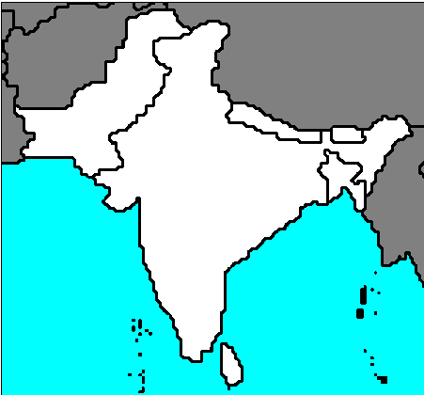

- The viability of a state depends on a balance between centripetal and centrifugal forces.
  - Define the concepts “centripetal force” and “centrifugal force.”
  - Give a specific example of and explain a centripetal force that affects the viability of any of the states shown on the map above.
  - With reference to a different specific example, explain a centrifugal force that affects the viability of any of the states shown on the map above.

- The modern state system is engaged in a struggle between forces of supranationalism and devolution.
  - Define both terms and give a geographic example of each.
  - With reference to the political and economic geography of Europe, briefly discuss three changes resulting from supranationalism.
  - With reference to the political and economic geography of Europe, briefly discuss three changes resulting from devolution.

