Within the nearest billion, how much was spent on the 2016 elections?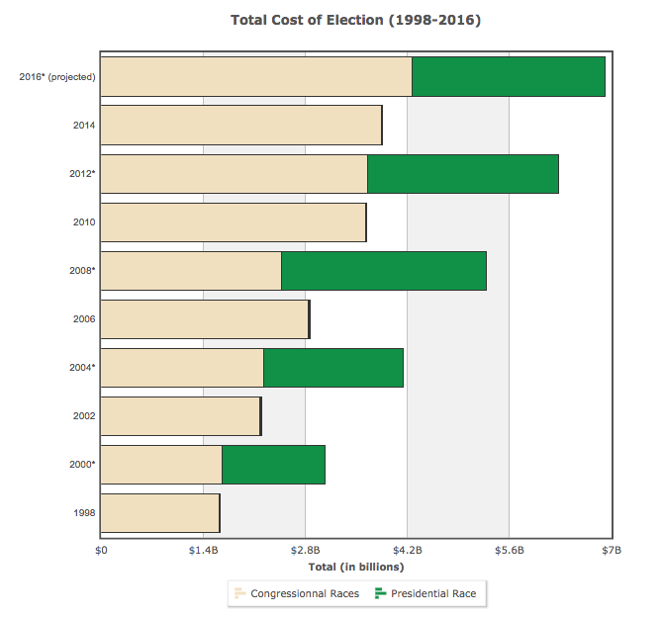
OPEN SECRETS

Answer the following questions on a separate sheet of paper to turn in next class.

What trend do you see in the data?

Why do you think that is?

What is one consequence of this?

What is the primary effect of this over $7 billion being spent in this year's elections?

Who is all this spending good for?

Who is this bad for?

Overall, is this good or bad news for democracy?

Does all this money help us become more educated, informed, or wise in our political choices?

What are some other positive ways $7 billion could be spent?

Where does most of this campaign spending go?

Which cost more, presidential or congressional races?

What American elections are not even included in this data?

As the amount of money spent on elections increases, the percentage people voting decreases. Explain this paradox.

What would be two possible ways to decrease the amount of money in elections?

How different do you think this year's presidential election would have been had there been a strict limit on campaign spending?

Based on this chart, how much money would you project will be spent in the 2020 elections?

Learning Extension

Scroll through Open Secret's detailed charts and graphs to get a good idea of the total impact of money in presidential politics.

Action Extension

Here's a list from Bill Moyers of 8 things you could do to help get money OUT of politics.

And here's a list from me of 1 thing you could do to help get money INTO politics: give money to a candidate!

Read these lists and do one of the things! Share your action on social media or in class.

Bonus Chart

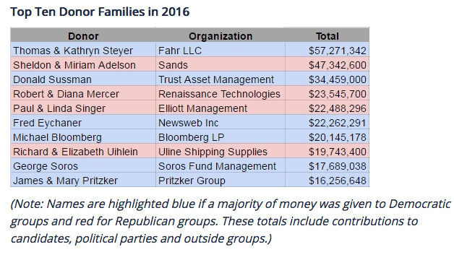
OPEN SECRETS

