AP Human Geography
Models & Theories FRQ Review
In 1798 Thomas Robert Malthus published An Essay on the Principle of Population in which he argued that population growth will inevitably outpace food production, resulting in widespread famine.
- Identify and explain TWO reasons why some geographers today believe Malthus’ theory can be used to predict future population issues.
- Identify and explain TWO reasons why some geographers today believe Malthus’ theory cannot be used to predict future population issues.
______________________________________________________________________________________________________________________________________________________________________________________________________________________________________________________________________________________________________________________________________________________________________________________________________________________________________________________________________________________________________________________________________________________________________________________________________________________________________________________________________________________________________________________________________________________________________________________________________________________________________________________________________________________________________________________________________________________________________________________________________________________________________________________________________________________________________________________________________________________________________________________________________________________________________________________________________________________________________________________________________________________________________________________________________________________________________________________________________________________________________________________________________________________________________________________________________________________________________________________________________________________________________________________________________________________________________________________________________________________________________________________________________________________________________________________________________

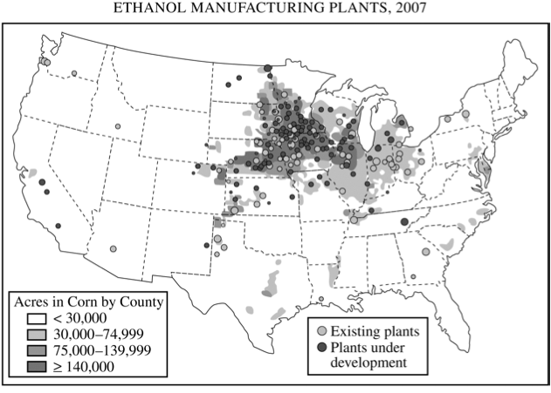
According to Alfred Weber’s theory of industrial location, three factors determine the location of a manufacturing plant: the location of raw materials, the location of the market, and transportation costs.
- Using an example of a specific industry other than the one portrayed on the map above, explain under what conditions an industry would locate near the market.
- Using an example of a specific industry other than the one portrayed on the map above, explain under what conditions an industry would locate near raw materials.
- Using the map above and Weberian theory, explain the geography of ethanol plants in the United States.
________________________________________________________________________________________________________________________________________________________________________________________________________________________________________________________________________________________________________________________________________________________________________________________________________________________________________________________________________________________________________________________________________________________________________________________________________________________________________________________________________________________________________________________________________________________________________________________________________________________________________________________________________________________________________________________________________________________________________________________________________________________________________________________________________________________________________________________________________________________________________________________________________________________________________________________________________________________________________________________________________________________________________________________________________________________________________________________________________________________________________________________________________________________________________________________________________________________________________________________________________________________________________________________________________________________________________________________________________________________________________________________________________________________________________________________________________________________________________________________________

Von Thünen’s model of land use and Burgess’ model of land use are similar in appearance but different in their geographic setting. Analyze and discuss the two models in terms of each of the following:
- For each of these models, identify the type of land use the model addresses.
- Identify two assumptions that are shared by both models.
- For each of these models, explain how relative location affects land-use patterns.
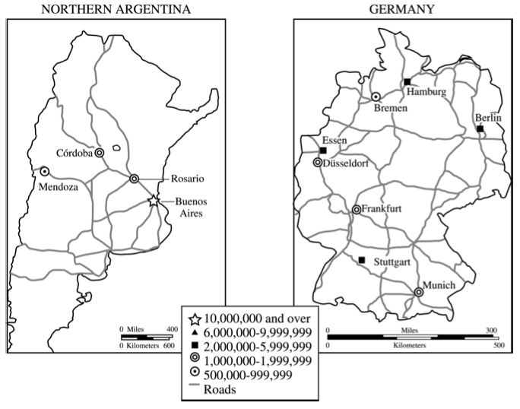
Discuss THREE ways in which the concept of core-periphery relations helps explain the development of urban systems shown above. Be sure to use evidence from both maps to support each of your conclusions.

________________________________________________________________________________________________________________________________________________________________________________________________________________________________________________________________________________________________________________________________________________________________________________________________________________________________________________________________________________________________________________________________________________________________________________________________________________________________________________________________________________________________________________________________________________________________________________________________________________________________________________________________________________________________________________________________________________________________________________________________________________________________________________________________________________________________________________________________________________________________________________________________________________________________________________________________________________________________________________________________________________________________________________________________________________________________________________________________________________________________________________________________________________________________________________________________________________________________________________________________________________________________________________________________________________________________________________________________________________________________________________________________________________________________________________________
Over the last 150 years, Europe has changed from a source to a destination region for international migration.
- Use the demographic transition model to explain briefly Europe’s development as a source of international migrants between 1800 and 1920.
- Identify and briefly explain ONE factor other than demographic transition that was responsible for Europe’s development as a source of migrants to the United States between 1800 and 1920.
- Briefly explain how THREE aspects of the demographic transition model account for Europe’s transformation into a destination region for migrants from North Africa between 1960 and 2000.
________________________________________________________________________________________________________________________________________________________________________________________________________________________________________________________________________________________________________________________________________________________________________________________________________________________________________________________________________________________________________________________________________________________________________________________________________________________________________________________________________________________________________________________________________________________________________________________________________________________________________________________________________________________________________________________________________________________________________________________________________________________________________________________________________________________________________________________________________________________________________________________________________________________________________________________________________________________________________________________________________________________________________________________________________________________________________________________________________________________________________________________________________________________________________________________________________________________________________________________________________________________________________________________________________________________________________________________________________________________________________________________________________________________________________________________________________________________________________________________________
_______________________________________________________________________________________________________________________________________________________________________________________________________________________________________________________________________________________________________________________________________________________________________________________________________________________________________________________________________________________________________________________________________________________________________________________________________________________________________________________________________________________________________________________________________________________________________________________________________________________________________________________________________________________________________________________________________________________________________________________________________________________________________________________________________________________________________________________________________________________________________________________________________________________________________________________________________________________________________________________________________________________________________________________________________________________________________________________________________________________________________________________________________________________________________________________________________________________________________________________________________________________________________________________________________________________________________________________________________________________________________________________________________________________________________________________

