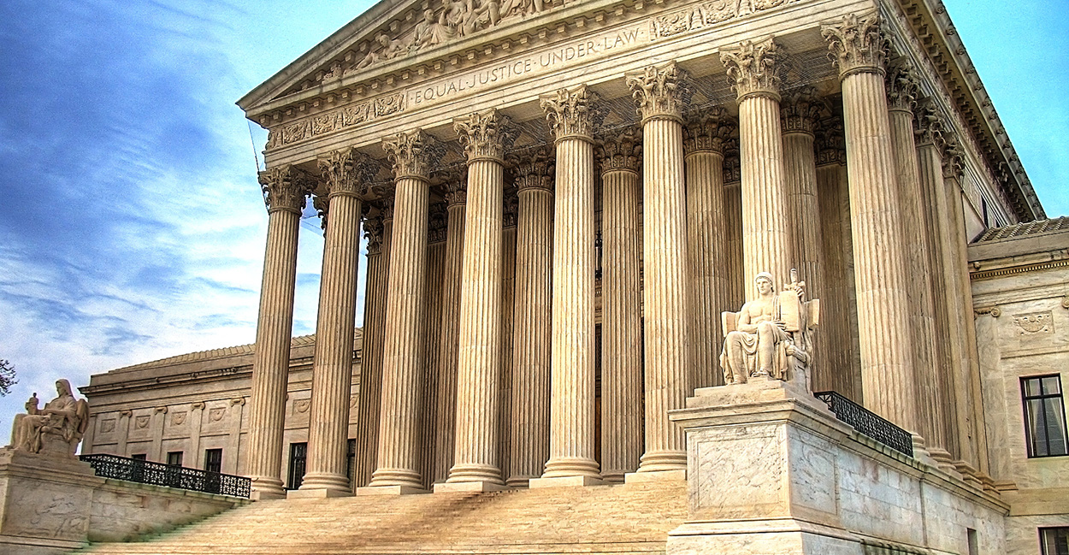

2) McCulloch v Maryland (1819)

Compelling Question

Does the federal government have too much power?
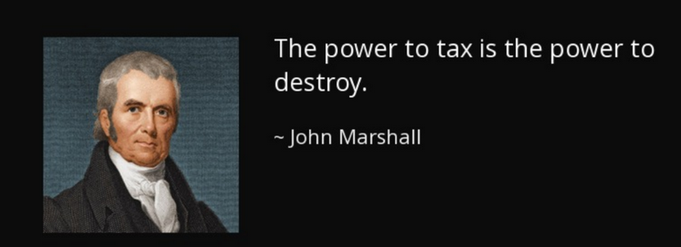

Facts of the Case
After the War of 1812, (when was that?) the U.S. government needed additional funds to pay off the debts of the war. At the time, there was no central US national bank, so instead of being able to borrow money from one institution, the government had to work with multiple state banks. How inefficient! As a result, in 1816, Congress set up the Second Bank of the United States with branch offices in multiple locations and convenient horse and buggy drive through service. Many states opposed the National Bank because the state banks then had to compete for business. In response, Maryland passed a law requiring the national bank to pay a heavy tax to the state of Maryland. James McCulloch, the bank's bad-to-the-bone cashier, refused to pay the tax!
McCulloch was convicted of failing to pay the tax and was fined $2,500. He appealed the case to the Maryland Court of Appeals, which upheld the decision of the lower court and affirmed McCulloch's conviction. The dispute reached the Supreme Court of the United States.
The Court Considered These Constitutional Questions:
- Did Congress have the power to establish a national bank?
- Did the Maryland law to tax the nationally chartered bank unconstitutionally interfere with federal powers?
- Do we look fat in these robes?

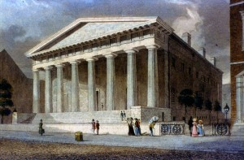

“Let the end be legitimate, let it be within the scope of the constitution, and all means which are appropriate, which are plainly adapted to that end, which are not prohibited, but consist with the letter and spirit of the constitution, are constitutional.”

– John Marshall

Fun Facts
- When the Maryland courts upheld this law, the Bank, in the name of its Baltimore branch cashier James W. McCulloch, appealed to the Supreme Court. Who said bank tellers couldn't be famous!?!
- Daniel Webster, with William Pinkney, argued the case on behalf of the Bank. Luther Martin argued the case on behalf of Maryland.
- The First Bank of the United States was chartered by Congress for 20 years on February 25, 1791. The concept of the bank was the brainchild of Alexander Hamilton, the first Secretary of the Treasury and a visionary for the great future of America.
- John Marshall was the chief justice presiding over a landmark case - again!
- There were seven Supreme Court Justices when the case was decided. The ruling was unanimous, but Justice Thomas Todd did not take part in the ruling. On March 29, 1812, Todd had married Lucy Payne Washington, the youngest sister of Dolley Madison and the widow of Major George Steptoe Washington, who was a nephew of President George Washington. It is believed to be the first wedding held in the White House.
- Supreme Court Justices do look fat in their robes.

Sources
Oyez - McCulloch v Maryland
Crash Course Video - Federalism
National Archives Primary Source - McCulloch v Maryland ruling
Relevant Excerpts of the Constitution:
- The Necessary and Proper Clause (Article I, Section 8, Clause 18)
"The Congress shall have the Power ... To make all Laws which shall be necessary and proper for carrying into Execution the foregoing Powers and all other Powers vested in this Constitution."
The Necessary and Proper Clause is also known as the "Elastic Clause" because its meaning may be stretched to allow Congress to pass a variety of laws.
- The Supremacy Clause (Article VI, Clause 2)
"This Constitution, and the Laws of the United States which shall be made in pursuance thereof ... shall be the supreme Law of the Land; and the Judges in every State shall be bound thereby, any Thing in the Constitution or Laws of any state to the Contrary notwithstanding."
This part of the Constitution specifically states that federal laws take priority over state laws.
- The Tenth Amendment
"The powers not delegated to the United States by the Constitution, nor prohibited by it to the States, are reserved to the States, respectively, or to the people."
Main Arguments for McCulloch:
- Although the power to charter a national bank is not specifically mentioned in the Constitution, it is one of the implied powers that the Necessary and Proper Clause grants Congress.
- The bank is a "necessary and proper" way for Congress to conduct the financial affairs of the country.
- If Maryland is allowed to tax the bank, the state could destroy the bank by taxing it so much that it would have to close.
Main Arguments for Maryland:
- The right of the national government to establish a bank is not specifically granted in the Constitution.
- It is also not an implied power, so Congress had no right to establish a national bank.
- The power to establish banks is reserved for the states.
- States are sovereign (they have complete and permanent authority over themselves), so they have the authority to tax institutions and businesses in their borders.
Main Arguments for Pizza:
- Easy to divide evenly.
- Tastes great.
- Can eat with hands!
- Can be used as a Frisbee in an emergency.
- Everybody loves pizza.
The Court's Decision:
The Court unanimously ruled in favor of the national government's right to establish the bank and also found that the state did not have the power to tax the institution.
Chief Justice Marshall, writing for the Court, stated that the federal government possessed powers that were not explicitly expressed in the Constitution, known as implied powers. Although the federal government did not specifically have the power to charter a national bank, the national Congress did have the authority to make all laws "necessary and proper" to accomplish other tasks.
Marshall also held that even though the states retained the power of taxation, "the constitution and the laws made in pursuance thereof are supreme ... they control the constitution and laws of the respective states, and cannot be controlled by them." Maryland did not have the ability to tax a federal establishment. Taxing the national bank was really an attempt by the state to destroy the bank, and this was a challenge to the federal government's constitutional supremacy.
The Court did not rule on pizza, as it had not been invented yet.

For your Consideration
Imagine life without The Necessary and Proper Clause, where the federal government is limited to only enumerated powers listed in Article I, Section 8 of the US Constitution. Think about how different the government and American life would be.
Imagine life without The Supremacy Clause, where much like America under the Articles of Confederation, the federal government is no longer superior to the states. Think about how different the government and American life would be.
- When there is a conflict between state and federal government, who wins and why?
- Is the growth of the federal government which McCulloch v Maryland made possible a good thing?
- Is there ever a situation when different states need to have different laws? (Note – wildlife protection or awareness need not apply)
- If you were John Marshall how would you have ruled in McCulloch v Maryland?
- How would the U.S. political system be different without McCulloch v Maryland?

