Northampton County, Virginia:
The Front Line of the Home Front during World War I

Katherine Snyder Lacks
HIS 803: Historical Methods
Dr. Douglas Biggs
Spring 2019

In April 1916, President Wilson arrived on Tangier Island, a small community in the Chesapeake Bay just over ten miles west of Virginia’s Eastern Shore. When the President, the First Lady, and their entourage stepped off the boat, they were confused that the streets suddenly emptied, doors closed, and windows covered. Only one man remained outside to greet the strangers. President Wilson approached the man, who slowly and skeptically realized he was the president, and explained the reason for retreat. The residents of Tangier, seeing an unknown vessel approaching the harbor, believed the Germans were invading, much like the British had during the War of 1812. The man proceeded to state that his personal fears had only subsided when he saw Mrs. Wilson, as he assumed no woman would travel with the German Navy. This story, from Edith Wilson’s memoir, highlights the fear that citizens of the Eastern Shore harbored about a possible invasion by the enemy during World War I.
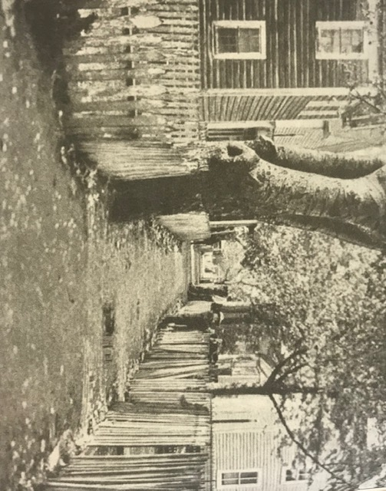
“Main Ridge, Tangier Island” Harper’s Magazine (1913)
Virginia’s Eastern Shore is a seventy-two-mile long peninsula situated between the Chesapeake Bay and the Atlantic Ocean. The Eastern Shore and its surrounding islands were first explored and mapped by Captain John Smith in 1608; however, recent archeological findings and historical records suggest that British, French, and Dutch settlers may have visited prior to the founding of Jamestown. As the cradle of British civilization in North America, Northampton and Accomack counties have been inhabited by Europeans since Smith’s early visits, and as a result, Northampton County, the southernmost of the two, houses the oldest, most continuous records in the United States.
Due to the difficulty in navigating the barrier islands off the Atlantic coast of the Eastern Shore, the peninsula did not urbanize like other areas along the mid-Atlantic coast. Instead, it remains an agricultural and aqua-cultural community. However, its geographic location has allowed it to play an integral role regarding the shipments of essential goods to northeast cities, as well as shielding the port of Norfolk and its naval base from heavy seas and even possible invasion. Eastern Shore citizens watched as the French fleet saved the war effort during the American Revolution, and the British sailed up the Chesapeake during the War of 1812. When Virginia seceded at the onset of the Civil War, the Union quickly occupied the Eastern Shore to establish dominance in the Chesapeake Bay.
The Eastern Shore was central to these key events in American history, and continued to play a role in the world wars of the 20th century. When World War I erupted in Europe, Eastern Shore citizens felt threatened by the possibility of German advances, even though the war was fought over four thousand miles to the east. While this fear did not seem to dominate society, it did breed considerable paranoia. To what extent did this paranoia inspire both local citizens and the federal government to take action on the Eastern Shore during World War I? The Eastern Shore of Virginia represented the front line of the American home front during World War I in terms of military mobilization, federal government intervention, and citizen readiness.
This article will first examine the increased Coast Guard presence in Northampton County during World War I. Virginia was more involved than most states due to its proximity to Washington DC, as well as housing Norfolk Naval Base and Newport News Shipyard. The Hampton Roads area was already reaping the economic benefits of the war prior to US entry, specifically in terms of food and coal shipments to the Allies. Therefore, Eastern Shore citizens had increasing reasons to be concerned. Upon entry, American Expedition Forces launched from Norfolk, past the Eastern Shore, and headed for France. With the decrease of Army and Navy personnel at home came an increase in Coast Guard presence on the Eastern Shore, specifically in Cape Charles and on the barrier islands.
Second, Northampton County citizens experienced government seizure of property, and an increase in the construction or use of bases and lighthouses. The US House of Representatives financed the building of new quarantine facilities on Fisherman’s Island, the southernmost point of the Eastern Shore, to house those diagnosed with the Spanish flu and other contagious diseases. New naval bases were constructed on Cherrystone Island in the Chesapeake Bay as well as on Fisherman’s Island. Keepers maintained constant vigil at Smith Island and Hog Island lighthouses for enemy ships and submarines. Beaches along the barrier islands were patrolled to watch for German spies arriving in smaller vessels. The US Navy also established training bases for sailors near Cape Charles.
Third, Eastern Shore citizens seemed supportive of US intervention during the war; no records indicate dissention. Citizen groups were formed to aid the war effort. The Cape Charles Branch of the National League for Women’s Service was organized to make and collect items to send to troops overseas, specifically for the local National Guard Unit, Company H, which was called into active service and sent to France. The American Red Cross established a Cape Charles chapter in December 1917 which soon expanded to include many other branches in Northampton County. Meanwhile, farmers and railroad companies increased production and shipments from Hampton Roads, sending goods northeast through the Eastern Shore and on to northern cities, which also contributed significantly to the modernization of both counties.
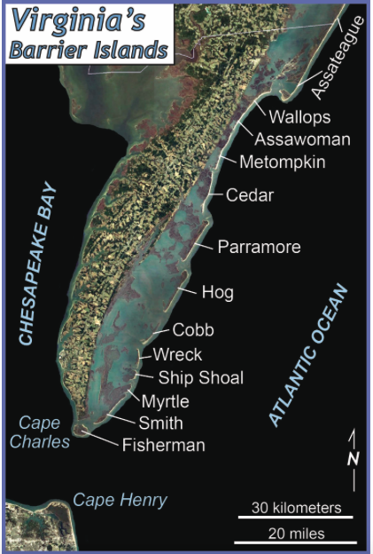
Fifteen barrier islands protect the Eastern Shore from the Atlantic Ocean. Most were inhabited until the mid-20th century, at which point remaining citizens allowed nature to finish its course of consistently challenging communities to stay intact. Over time, storm surges and rising sea levels erased signs of human development. Remnants of entire towns that once thrived live only beneath the sea, and as a result, the Virginia barrier islands represent the only undeveloped island system on the east coast of the US. Most are currently owned and protected by the Nature Conservancy’s Virginia Coast Reserve, and the National Wildlife Refuge.
The waters that break onto the barrier islands can be treacherous. In the 1870s and 1880s, nine life-saving stations were established by the US government on the islands to help captains and crew who failed to navigate to shore successfully. The stations were usually one-story buildings with watchtowers and attached boat docking areas. While most islands boasted populations of 250 people or fewer, many were tourist destinations. Visitors from the northeast could take the New York, Philadelphia, and Norfolk Railway (NYP&N) to Exmore, VA and board ferries to the islands to visit the Broadwater Club on Hog Island, and Nathan Cobb’s hotel on Cobb Island. During his presidency, Grover Cleveland visited Hog Island in 1892 and Cobb Island in 1893 for hunting and fishing expeditions. Most travels to and from the islands were launched from the Eastern Shore mainland; however, over 400 known ships wrecked along the Atlantic coast since the 1770s. The Life Saving Service was formally recognized as a department within the US Department of the Treasury in 1878. In 1915, President Wilson created the Coast Guard, which took control of the life-saving stations, and converted them to two-story rectangular structures with increased living and storage space. The US Navy temporarily commanded the Coast Guard in both World War I and World War II.
College of William & Mary, “Geology of the Eastern Shore” (2014).
As the US contribution to the war effort increased, fear of German invasion escalated. Increased military presence around the Eastern Shore in 1915 sparked paranoia in its citizenry. While war raged in Europe, German naval vessels threatened US shipping. In January 1915, the SMS Prinz Eitel Friedrich sank the William P. Frye, a US merchant ship carrying wheat to Britain. Concerned that the British and French would take revenge, Captain Max T. Thierichens of the Eitel sought protection by entering the Chesapeake Bay and seeking refuge at the port of Hampton Roads in Newport News. The arrival of the German ship was concerning for many reasons, the most obvious of which was that military forces had not seen the ship as it slipped between the Virginia Capes Charles and Henry, sailing unnoticed past the world’s largest naval base. However, the Eitel arrived in peace. International law permitted a twenty-four-hour furlough for belligerent vessels in a neutral port for repairs, after which point it must leave or seek internment.
The Department of Defense had many concerns about merely allowing the German ship to return to active duty. Captain Thierichens ignored his personal eagerness to return to war and decided after almost a month’s stay in port to intern his ship. Thus, he and 400 German crew members were fated to wait out the war in Virginia. In the meantime, the US Navy mobilized at home. Ships were crewed, left the docks, and were anchored in the harbor to show readiness. The USS Alabama and many submarines and destroyers were sent from other east coast ports to guard the capes. The British and French also sent warships to the entrance of the Chesapeake Bay to defend it from potential German attackers. Even though the US was not a belligerent participant at this point, the British and French were reliant on American products, specifically food items and coal, for the war effort. Thus, defending the port of Virginia became imperative for their governments as well. Safety precautions were implemented to guard the Eitel throughout its internment.
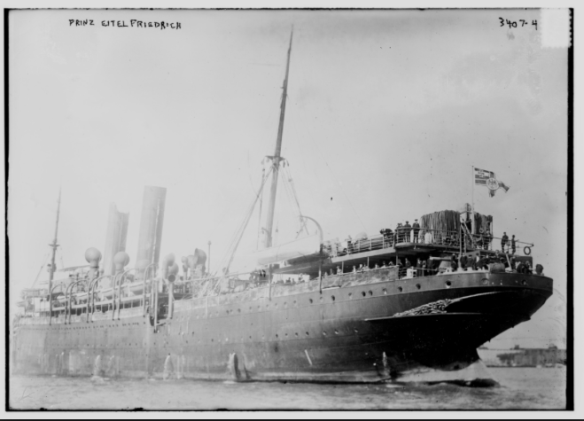
Library of Congress, SMS Prinz Eitel Friedrich (1915)
Much to the dismay of President Wilson and the War Department, the Eitel was not the only German ship that entered the Chesapeake Bay prior to US entry into the war. Less than a month later, the SMS Kronprinz Wilhelm with a crew of 454 German sailors approached the capes due to rampant illness on board. Even though six British destroyers sat between it and the point of entry, the German captain Count Niezychowski proceeded carefully towards the coast, the band aboard playing the “Star Spangled Banner.” The US allowed the Kronprinz Wilhelm internment despite significant British frustration.
In 1916, the German steamship the Appam also came to Hampton Roads seeking refuge. The Deutschland, a German merchant submarine, passed through the blockade to dispense cargo and refuel but stayed for three weeks upon learning of other German sailors in the area. The inability for the US or British navies to stop German entry was highly concerning to the Allies; however, once the German sailors disembarked upon US shores they were mostly met with courtesy. Over 800 members of the German navy stayed in the US throughout the course of the war. Even after US entry, they enjoyed many of the freedoms of US citizens. They asked for and were granted permission to watch baseball games, celebrate American holidays, and attend church. They received the right to travel domestically, even using the Cape Charles Ferry System to connect to New York.
As a result of the continued presence of German ships, and as the US got closer to potentially joining the war, Coast Guard activity along the Eastern Shore also increased. In June 1917, less than three months after the US declared war on Germany, Congress passed Wilson’s Espionage Act which included provisions that required the Coast Guard to safeguard coastal properties, establish restricted areas of vessel movement, and to supervise vessel movement. Constant vigilance at newly acquired life-saving stations became mandatory.
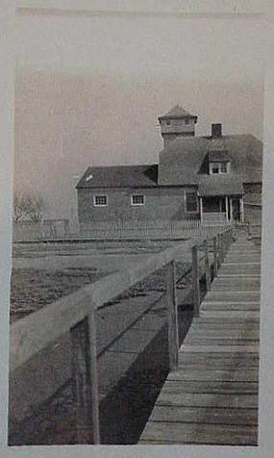
Hog Island, the northernmost barrier island in Northampton County and home to one of the first settlements in British North America, felt few immediate effects of the war. No islanders volunteered for service. Two islanders were drafted, but Hog Island Bay, situated between the island and the Eastern Shore mainland, froze during the winter of 1917-1918, and the draftees did not receive their notice for weeks. It is unclear if they ever reported for duty. Meanwhile, Coast Guardsmen stationed on Hog Island consistently rotated watching the waters for enemy vessels. According to islanders, most servicemen complained of boredom. Due to the monotony involved in this line of defense, but also the importance of consistency, the Coast Guard scheduled men for brief stints on the island.

Old Coast Guard Station and Dock, Courtesy of Yvonne Widgeon, former Hog Island resident

The same was true of two other islands with Coast Guard stations in Northampton County, Cobb and Smith. While Parramore Island in neighboring Accomack County had sixteen Coast Guardsmen and Assateague Island had four separate stations, most of the others had one officer in charge and an additional seven or eight men, all of which rotated watch day and night. Citizens also contributed to this effort by patrolling the island beaches in search of German sailors or spies in smaller vessels or submarines. No Coast Guard records indicate that enemy vessels were ever spotted off Northampton County’s barrier islands specifically. However, local newspapers reported sightings of German U-boats off the coast, which heightened citizen paranoia. According to the National Museum of the US Navy, German U-boats did come to Virginia’s shores. Specifically, a U-140 sank at least four merchant vessels off the Virginia capes in 1918. A U-15, which had previously sunk thirteen US merchant vessels, damaged three small schooners off of Cape Charles the same year.
In addition to the Coast Guard takeover of life-saving stations and increased activity at each, other infrastructure was either redesigned, constructed, or experienced increased use as a result of the war. In 1890, a quarantine station and marine hospital were built south of Cape Charles on Fisherman’s Island off the southernmost point of the Eastern Shore. In March 1916, the US House of Representatives agreed to appropriate money for improved quarantine stations in Cape Charles and Oregon. The Fisherman’s Island station was meant to house European immigrants coming to the US who potentially suffered from influenza. In December 1917, the Secretary of the Treasury asked Congress for more money to expand the station. The request included appropriations
“For seven barracks buildings, three mess halls, officers’ quarters, remodeling buildings, heating plant and plumbing, lighting plant and equipment, disinfection building and equipment, laundry building and equipment, sewage, drainage, and approach work, hospital building and equipment, $143,500; disinfecting and boarding vessel, $40,000; miscellaneous furnishing and equipment, $42,326; in all, $225,858.”

The House of Representatives funded the request, thus significantly expanding medical and military operations on the island. A few months later, Surgeon General Rupert Blue requested more money for another boarding and disinfecting vessel for both Cape Charles and Boston quarantine stations. Blue described the situation at both stations as urgent, and Congress quickly appropriated additional funds. Fisherman’s Island also housed a crematorium for immigrants who died of an infectious disease upon arrival to the US. The island experienced increased use during the war by the US Navy for shoreline defensive purposes. By World War II, it was home to Fisherman’s Island Naval Station.
In 1917, the US government seized control of Sandy Island in the lower Chesapeake Bay off the coast of Cape Charles. The small island was home to the Dennis Fish and Oil Company, which caught and processed Atlantic menhaden, one of the most common commercially fished species on the East Coast. The War Department closed the business and commandeered all vessels for the war effort. The Navy used the island as a lookout and refueling station, as a docking area for a patrol fleet, and as an officer training camp. Barracks soon occupied the former fish factory floor, and 200 sailors were brought to the island in addition to the former fish company employees who were drafted into service because of their knowledge of the surrounding waters. Due to its proximity to Cherrystone Creek, the island was renamed Cherrystone Naval Base, and also included a naval hospital. In addition to US naval presence, local citizens also helped patrol the Eastern Shore coastline in the Chesapeake Bay, around the southern cape, and off the Atlantic coast.
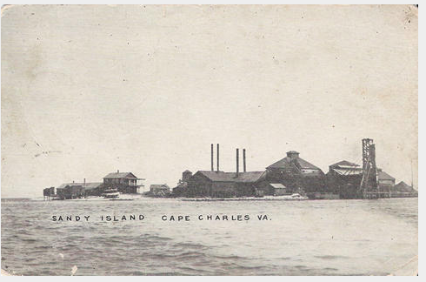
Dennis Fish & Oil Company, Sandy Island, Va.

The US army commissioned a training camp for soldiers just south of Cape Charles during the war. This camp evolved into Fort Winslow in 1941, later adopting the name Fort John Custis after one of the Eastern Shore’s original, prominent citizens. The US Air Force acquired the fort in 1948, and in 1950 renamed it Cape Charles Air Force Station.
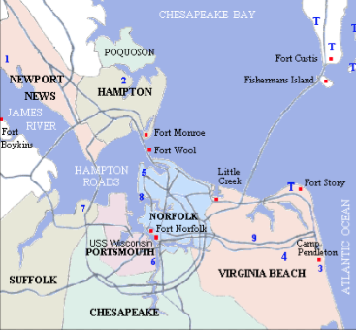
Chesapeake Bay Harbor Defenses, “Seacoast Forts of Hampton Roads” (2004).

On December 26, 1917, President Wilson nationalized the railroads. The Eastern Shore was significantly affected since it hosted the main railway line from Norfolk to New York. The government used the NYP&N Railroad Company for the war effort, which included rails and ferries. The government seized barges and boats owned by the company that ferried goods, people, and cars between Cape Charles and Norfolk, a twenty-six-mile route across the Chesapeake Bay. The ferry system came explicitly under the control of the Navy who also gained control over the Virginia Fisheries Commission, a state-sponsored organization that managed saltwater fishing and aqua-culture zoning for the purpose of preservation and safety. The Navy used all persons and vessels of the Virginia Marine Resource Commission (VMRC) for harbor security and coastline patrol.
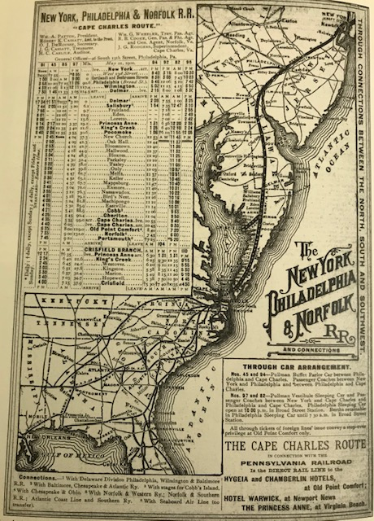
“The New York, Philadelphia, & Norfolk Railroad (1900.” In Chris Dickon, Images of Rail: Eastern Shore Railroad. (Charleston, SC: Arcadia Publishing, 2006), 20.

The Lighthouse Service, or Bureau of Lighthouses, was established in 1910 as part of the Department of Commerce but was transferred to the control of the Navy in early 1917. The Navy prohibited civilians from visiting lighthouses throughout the duration of the war, and lighthouse operations changed dramatically. Lighthouse vessels were suddenly responsible for setting submarine nets and planting mines. Keepers and signalmen were required to keep watch twenty-four-hours per day, and daily signal practice became mandatory. Detailed logs of watches were required and included times of signal practice, signals sent and received, and all aircraft and passing vessels seen, including names, type, and direction of travel. The Navy provided additional instructions for special circumstances such as the presence of enemy aircraft or vessels and the sound of gunfire, and distributed specific rules regarding cleanliness and supplies. The Navy instructed each signalman to purchase enough provisions and supplies to last thirty days before arriving at his assigned location. By April 1917, President Wilson ordered that the Navy seize full operational control of certain lighthouses, including Smith Island lighthouse, also called Cape Charles Light. Enlisted sailors, including signalmen and electricians, were sent for lighthouse service but were subordinate to the principal keepers, who had superior knowledge of the landscape, operations, and tides. Records indicate that members of the armed forces sometimes struggled to take orders from keepers.
Cape Charles Light was initially constructed in 1828 with white brick and underwent several renovations as a result of environmental damage or fire. It was rebuilt entirely in 1893 as a 191-foot-tall, steel, pyramidal skeletal tower, making it the second tallest lighthouse in the US behind Cape Hatteras Light. Cape Charles Light’s sister lighthouse, Hog Island Light, was also rebuilt with an exoskeleton of steel, and stood at the southern end of the island near the town of Broadwater. Before the war, multiple buildings were added to Smith Island to accommodate the keeper and proved useful for the Navy during the war years. Both lighthouses were manned continuously during the war for navigational purposes and to preemptively spot the enemy. In 1919, the Lighthouse Service was relinquished from the Navy and returned to the Department of Commerce, only to be restructured again in 1939 under the Coast Guard. Both lighthouses were again consistently occupied with military personnel throughout World War II.
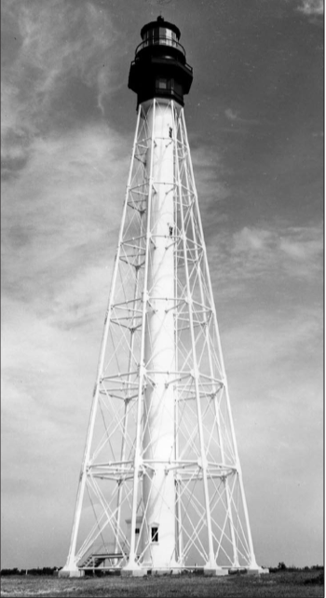
Virginia Department of Historic Resources, Cape Charles Light (1894)
The agricultural economy of the Eastern Shore turned on the production of wheat, cotton, soybeans, corn, white and sweet potatoes, cabbage, onions, and strawberries in the early 20th century. Aqua-farmers harvested oysters, clams, and blue crabs. Commercial fisherman caught gray sea trout and croakers for human consumption, and also menhaden for oil and by-products. When the NYP&N Railroad Company installed ventilators in boxcars, farmers and watermen expanded their networks to northeast cities. By the onset of World War I in Europe, Eastern Shore foods could reach New York in twelve hours, Boston in twenty hours, and Montreal in thirty hours. Farmers also ferried crops to Norfolk for shipment overseas and to western cities. Demand for oysters in particular was high in cities like Chicago, Kansas City, Minneapolis, and Omaha, and oystermen soon learned they could shuck the oysters first to get a higher return; this led to the opening of shucking houses throughout the county. In the first two decades of the 20th century, Virginia oyster harvests neared six million bushels per year.
By 1916 the demand for grain in Great Britain and France meant that farm prices were also high, and farmers had no fear of overproduction. Over the course of the year, over 250,000 freight cars crossed the Chesapeake on NYP&N barges. By the time the US entered the war, Eastern Shore farmers were getting the highest rates ever recorded for their crops. In 1918, twenty-five to thirty railroad cars of potatoes alone were passing through Cape Charles daily. By the war’s end, Eastern Shore sweet potato production nearly reached three million bushels per year, while white potato production exceeded twelve million bushels per year.
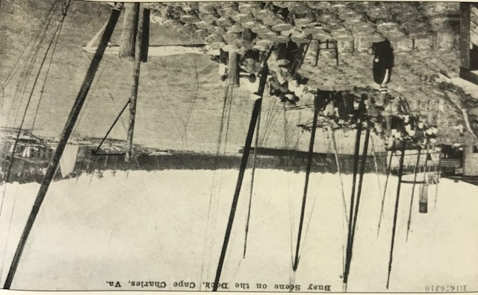
“Busy Scene on the Dock, Cape Charles, Va. 1916.” In Chris Dickon, Images of Rail: Eastern Shore Railroad. (Charleston, SC: Arcadia Publishing, 2006), 44.

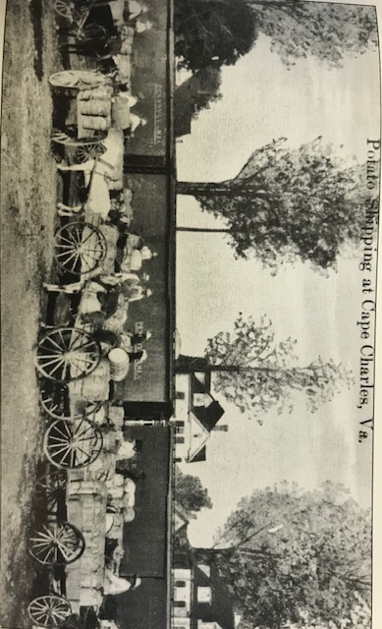
“Potato Shipping at Cape Charles, Va. 1918.” In Chris Dickon, Images of Rail: Eastern Shore Railroad. (Charleston, SC: Arcadia Publishing, 2006), 45.

Farmers helped with the food effort by growing additional crops to donate, and citizens planted war gardens. Public school children cultivated gardens on school grounds. The local Service League gave rewards for the most successful gardens. Meanwhile, county administrators sponsored food campaigns and delivered lectures to remind citizens to use their resources wisely. Housewives learned to serve less meat and more vegetables as well as save all leftovers. Public school teachers were encouraged to discuss the importance of food and fuel conservation with their students, and school canning clubs and conservation clubs became prevalent.
In terms of direct service, Northampton County opened a local recruiting station at Cape Charles. Men who registered became part of Company H, which later merged into the 116th Virginia Infantry, a regiment that had existed as part of the Virginia National Guard since 1741. Over the first few months of the war, the men of Company H helped guard the coastline. In August 1917, the regiment was sent to Camp McClellan in Alabama for more training, and later to France where they joined other regiments within the American Expeditionary Forces in the Meuse-Argonne Offensive. This offensive marks one of the most extensive military operations during the war and represented the final Allied push to drive the Germans out of France, which ultimately ended the war. Over one million Americans fought in this campaign, resulting in 26,000 deaths and over 120,000 casualties. Twenty-one residents of Northampton County and thirty-one residents of neighboring Accomack County lost their lives in the war, mostly during this campaign.
In March 2017, the Cape Charles Branch of the National League for Women’s Service League organized. Women knitted quilts, sweaters, and socks for Allied forces and created comfort kits for local soldiers, which included a copy of the Bible. They also collected linens and abstained from using certain food items like wheat. Women of the Service League also volunteered as nurses at Cherrystone Naval Station and on Fisherman’s Island. They brought food and books for locally stationed soldiers and sponsored dances for them. The Service League also assisted in Liberty Loan and War Savings drives and worked with other organizations in the area to raise money and supplies.
In December 1917, the American Red Cross organized a Cape Charles chapter. Soon, seven additional branches and eleven auxiliary branches formed throughout the county. Over 1,300 residents joined the first year. From its founding to June 1919, the chapter raised over $12,000 and additionally contributed
“27,814 surgical dressings, 2,203 hospital garments, 920 knitted garments made, 149 Christmas boxes were sent overseas, 2,706 pounds of clothing, 100 handkerchiefs, 100 hand towels, 50 bath towels, 50 sheets and 100 napkins were sent to the Belgian relief. The chapter also contributed 721 surgical dressings to debarkation hospital Camp Stewart; 3,943 surgical dressings to US Naval Hospital, Norfolk, and a box of hospital garments and surgical dressings to the convalescent home, Hampton. An emergency aid was organized for Cherrystone Naval Base.”

The Red Cross and Service League converted an abandoned, dilapidated building on Pine Street in Cape Charles into a service club for the entertainment of sailors stationed at Cherrystone Naval Base and Fisherman’s Island. They cleaned and painted, and collected donations of furniture, rugs, wall hangings, and even a piano and a Victrola from local residents. When complete, four hundred to five hundred men per week visited the club for entertainment. The club later became a Red Circle Club operated by the War Camp Community Service.
Women of the Red Cross also worked with the War Relief Association of Virginia by sending monetary donations and in return receiving more hospital supplies for local bases. They also worked with this group to collect clothing and supplies to send to France to help wounded soldiers and refugees. They helped the Virginia Committee for Fatherless Children in France to collect donations of clothes, books, and toys for French orphans who were adopted by Virginians.
The Red Cross also established a Junior Red Cross to spearhead war efforts at schools. Local high schools held patriotic parties. Admission usually cost fifteen cents and all proceeds benefitted the Red Cross, who would also take additional material donations while administering war saving stamp booths.

Conclusion
World War I affected the citizens of the Eastern Shore in different ways than citizens in other areas of the US, mostly due to the fear of the German naval vessels lurking off the coast. Even before US entry, Eastern Shore residents experienced a significant increase in military personnel. The Navy formally commandeered the newly created Coast Guard, the long existing Lighthouse Service, and created two new bases on nearby islands, both with hospitals. Like in other areas of the country, the government nationalized the railroad, which was the lifeline of the Eastern Shore economy, but it also took control of local privately owned and state-sponsored businesses in response to growing fears of entering the war in Europe. Because the threat of German invasion seemed likely, citizens of the Eastern Shore needed little convincing in terms of supporting the war effort. Citizens joined organizations, attended lectures, and conserved food and fuel. They volunteered in hospitals and helped provide extra food and amenities for soldiers stationed in the area.
World War I allowed the economy of the Eastern Shore to flourish and modernized Eastern Shore society. When soldiers returned from the war, jobs were readily available in farming and seafood, as well as on the railroad. Despite the lack of industry, the population remained at its peak throughout the 1920s. The number of automobiles on the Eastern Shore increased so dramatically that the Virginia General Assembly had to impose specific driving restrictions for both Northampton County and Accomack County residents: no one under the age of twelve was permitted to operate an automobile, all cars had to be kept to the far-right side of the road to provide room for horses and buggies to continue to pass easily, and drivers had to use lights at night. By 1920, passenger travel by railroad through the Easter Shore was at full capacity. On an average summer day, over 4,000 people traveled the peninsula to northern cities or ferried across the bay. Six passenger trains departed from Cape Charles every day of the week, except Sunday when only three departed. Many were express trains to New York. By 1922, construction began on a new state road to accommodate increased traffic. Completed in 1931, Route 13 is a four-lane highway that runs south from the Maryland border seventy-two miles to the southernmost point, which now connects to the Chesapeake Bay Bridge-Tunnel. Ferry services also expanded exponentially to accommodate car traffic between Cape Charles, Norfolk, and Virginia Beach. Many watermen worked as ferry boat captains and deckhands in the offseason.
After the war, farmers continued to prosper, especially potato farmers. Many younger residents inherited farms, kept them working, and often even expanded them instead of leaving for jobs in larger cities. In the early 1920s, many homes were renovated to add refrigerators, electric water pumps, indoor plumbing, and full bathrooms. Church congregations pooled money to replace wooden churches with brick. The Eastern Shore economy continued to thrive throughout the 1920s; however, prosperity was short-lived as the effects of the Great Depression proved crippling for farmers. The Eastern Shore and its railroad experienced a renaissance during World War II but declined again in the decades following as fewer citizens engaged in farming, causing the number of farms to decrease. In 2010, the population of Cape Charles was just over one-third of what it was during World War I with just over 1,000 residents. A recent boom in tourism has started to revive the town.
Over the last one hundred years, most of the physical remnants of World War I have disappeared from the Eastern Shore landscape. Some of the life-saving stations on the barrier islands remain, but many have disappeared under shifting sands or into the Atlantic. The Nature Conservancy moved Cobb Island Station by barge eight miles to the Northampton County mainland, specifically to the town of Oyster, in 1998. It is currently for sale. The quarantine station and naval base at Fisherman’s Island are long gone: nature has taken both and left only a few signs of human contact. The island currently has no infrastructure except for a stretch of the Chesapeake Bay Bridge-Tunnel, which was constructed in the 1960s and connects the lower Eastern Shore and Virginia Beach. The island itself is uninhabited and is protected by the US Fish and Wildlife Service.

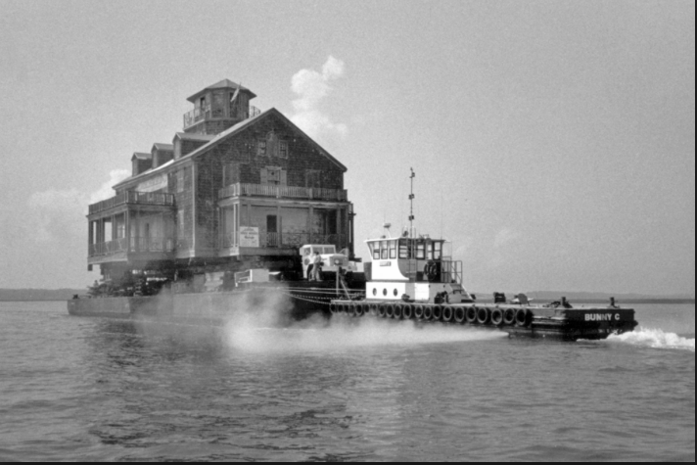
Cobb Island Station, on its way to the mainland (1998) https://bdarchitects.com/projects/cobb-island-coast-guard-station/
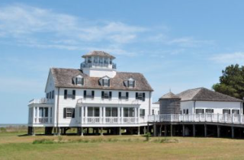
Cobb Island Station in Oyster, VA (2019) from Ralph W. Dodd & Associates, Realtor http://www.ralphwdodd.com/index.php/commercial/cobb-station/

Cherrystone Naval Base is nothing more than a sandbar and is covered by water at high tide. No buildings or docks exist even though the tide change is less than three feet. Fort Winslow, which became Fort Custis and later Cape Charles Air Station is also gone. Operated by the Air Force until 1981, it was replaced by the National Wildlife Refuge, which is also managed by the US Fish and Wildlife Service. The only remnant of the naval base is one old bunker and a gun barrel from the USS Missouri, the ship aboard which the Japanese surrendered during World War II. It also served in the Korean War, but returned to US shores in 1954.
The Coast Guard sold Smith Island to the Nature Conservancy in 1995. Most buildings were destroyed by fire in 2000, but the lighthouse itself and two small brick buildings remain. The Nature Conservancy recently sealed the lighthouse so members of the general public can no longer climb to the top. Meanwhile, Hog Island lighthouse was demolished with three hundred and fifty pounds of trinitrotoluene in 1948 after continued hurricanes caused such shifts in the island that the lighthouse was standing in the Atlantic. Its base is now nearly one mile out to sea. Before its destruction, the ten-foot high lens, designed at the Henry-LePaute Company in France, was removed and is now on display at the Mariner’s Museum in Newport News with the Smith Island light.
Even the railroad has left Cape Charles. Passenger service ended in the late 1950s, as did ferry service after the completion of the Chesapeake Bay Bridge-Tunnel in 1964. The railroad continued for cargo only and was taken over by several smaller companies until operations ended in 2018. Since, railroad lands have sold, and new owners are currently removing the tracks.
From 1914 to 1919, the US government and Eastern Shore citizens alike readied themselves for a German attack that never came. While U-boats occasionally dared to lurk beneath the seas which helped to fuel the Eastern Shore economy, no records indicate German soldiers besides those interned in Newport News ever dawned the shores of Northampton County. Despite this non-arrival, the paranoia that accompanied the possibility of intrusion was enough to inspire patriotism. Eastern Shore citizens wholeheartedly contributed to the war effort in hopes of defeating a Germany that they believed could invade at any moment.

Bibliography

Badger, Curtis and Rick Kellam. The Barrier Islands: A Photographic History of Life on Hog, Cobb, Smith, Cedar, Paramore, Metompkin, and Assateague. (Harrisburg, PA: Stackpole Books), 1989.

Barnes, Brooks M. and William G. Thomas III. “Northampton County in War Time: Community History.” (University of Virginia, 2008) http://eshore.iath.virginia.edu/node/2127

Barnes, Brooks M. and Barry Truitt. “A Short History of the Virginia Barrier Islands,” In Seashore Chronicles: Three Centuries of the Virginia Barrier Islands. (Charlottesville: The University Press of Virginia), 1997.

Buchanan, Mrs. F. F. and Mrs. Macon Hall McGuire. “Northampton County in War Time: A Community History.” In Virginia Communities in War Time. (Richmond: Virginia War History Commission), 1926.

Dabney, Virginius. Virginia: The New Dominion. (Charlottesville: University of Virginia Press), 1971.

Davis, Arthur Kyle. Virginia Communities in War Time. (Richmond: Virginia War History Commission), 1926.

“Delmarva Central Railroad Company – Change in Operator Exemption –Cassatt Management, LLC. D/B/A Bay Coast Railroad.” Surface Transportation Board. (May 17, 2018). "Docket No. FD 36196 - Delmarva Central Railroad Company - Change in Operator Exemption - Cassatt Management, LLC d/b/a Bay Coast Railroad".

Dickon, Chris. Images of Rail: Eastern Shore Railroad. (Charleston, SC: Arcadia Publishing), 2006.

Eshelman, Ralph E. and Patricia A. Russell. “Historic Context Study of Waterfowl Hunting Camps and Related Properties within Assateague Island National Seashore, Maryland and Virginia” (National Park Service), 2004.

“Government Enlisted Masters and Men of Dennis Company as Well as Taking Fleet.” Oil, Paint, and Drug Reporter, Vol. 92, No. 1 (July, 2, 1917).

Hansard, Gregory J. German Sailors in Hampton Roads: A World War I Story at Norfolk Naval Yard. (Charleston, SC: The History Press), 2018.

Henry, Ellen. “Lighthouses in World War I: Transition into War.” The Keeper’s Log (Winter 2014). https://media.defense.gov/2017/Aug/07/2001789112/-1/-1/0/2017-HENRYELLENUSLHS-WWI-ARTICLE.PDF

Kagawa, Ron M. and Richard J. Kellam. Cobb's Island, Virginia: The Last Sentinel. (Virginia Beach: The Donning Company Publishers), 2003.

Lewis, Jim. Cape Charles: A Railroad Town. (Eastville, VA: Hickory House), 2004.

Local News, Peninsula Enterprise, Volume 37, Number 32, 16 February 1918.

Marstad, Edna. Yesterday’s Hog Island. (Norfolk/Virginia Beach: The Donning Company/Publishers), 1985.

McHugh, J. L. and Robert S. Bailey. “History of Virginia’s Commercial Fisheries: Neglected Historical Records Throw Light on Today’s Problems.” The Virginia Journal of Science. (January 1957).

National Museum of the US Navy, Naval History and Heritage Command. “War Comes to America.” https://www.history.navy.mil/content/history/museums/nmusn/explore/photography/wwi/wwi-war-comes-to-america.html.

“Report of the Commission of Fisheries of Virginia. 1907–1967” (1907–1980). Commonwealth of Virginia; Office of the Commission of Fisheries, Richmond, VA.

Reynolds, Sarah J.. “Historical Architectural Survey, Eastern Shore, Accomack and Northampton Counties, Virginia.” Virginia Department of Historic Resources. June 2017.

Stockley. Georgia. “Accomac County in War Time.” In Virginia Communities in War Time. (Richmond: Virginia War History Commission), 1926.

The Nature Conservancy, Virginia Coast Reserve (2019) https://www.nature.org/en-us/get-involved/how-to-help/places-we-protect/vcr-barrier-islands/.

Thomas III, William, et al. “The Countryside Transformed: The Eastern Shore of Virginia, the Pennsylvania Railroad, and the Creation of a Modern Landscape.” (Charlottesville: University of Virginia Press, 2007). https://southernspaces.org/2007/countryside-transformed-eastern-shore-virginia-pennsylvania-railroad-and-creation-modern#footnote36_myphtw3

Turman, Nora Miller. The Eastern Shore of Virginia: 1603 – 1964. (Onancock, VA: Eastern Shore News), 1964.

U.S. Congress, House of Representatives, “Boarding Launches for Quarantine Stations.” 64th Cong., 1st sess, 1916. http://eshore.iath.virginia.edu/node/3379.

U.S. Congress, House of Representatives, “Deficiency Appropriations – Remodeling Buildings.” 65th Cong., 2d sess, 1917. http://eshore.iath.virginia.edu/node/3380

U.S. Congress, House of Representatives, “Quarantine Stations – Boston and Cape Charles.” 65th Cong., 2d sess, 1918. http://eshore.iath.virginia.edu/node/3389.

US Department of Commerce, NOAA, The Nature Conservancy. “Ecosystem Description.” (Virginia, 1976), https://www.govinfo.gov/content/pkg/CZIC-qh76-5-v8-n37-1976-v-1/html/CZIC-qh76-5-v8-n37-1976-v-1.htm.

U.S. Department of Homeland Security, United States Coast Guard, “Historian’s Office: 1900s – 2000s,” https://www.history.uscg.mil/Complete-Time-Line/Time-Line-1900-2000/

U.S. Department of Homeland Security, United States Coast Guard, “The US Coast Guard in World War I.” https://media.defense.gov/2017/Aug/07/2001789116/-1/-1/0/USCG-WWI-NARRATIVE.PDF

US Department of the Interior, National Park Service. “Cape Charles Light Station.” (1997). https://web.archive.org/web/20130813194748/http://www.dhr.virginia.gov/registers/Counties/Northampton/065-0071_Cape_Charles_Light_Station_2003_Final_Nomintation.pdf

US Department of the Interior, National Park Service, “National Register of Historic Places.” (2013). https://www.nps.gov/nr/feature/places/pdfs/64501177.pdf.

US Fish & Wildlife Service, Eastern Shore of Virginia Wildlife Refuge (2005). https://www.fws.gov/uploadedFiles/Region_5/NWRS/South_Zone/Chincoteague_Complex/Eastern_Shore_of_Virginia/ESVNWRbrochure.pdf

US National Archives, Military Records, “The Meuse-Argonne Offensive.” https://www.archives.gov/research/military/ww1/meuse-argonne.

Virginia Marine Resources Commission, “Historical Highlights of the Virginia Marine Resources Commission.” http://mrc.virginia.gov/vmrchist.shtm#nineteenseventeen

Wheeler, Wayne. “Cape Charles Light Station.” The Keeper’s Log (Summer 2005). https://uslhs.org/sites/default/files/articles_pdf/cape_charles.pdf.

Wilson, Edith Bolling. My Memoir (Indianapolis: Bobbs-Merril Co.), 1938.

Edith Bolling Wilson. My Memoir (Indianapolis: Bobbs-Merril Co., 1938), 96 – 98.
Virginius Dabney, Virginia: The New Dominion. (Charlottesville: University of Virginia Press, 1971), 463 – 464.
Jim Lewis, Cape Charles: A Railroad Town. (Eastville, VA: Hickory House, 2004), 63.
Arthur Kyle Davis. Virginia Communities in War Time. (Richmond: Virginia War History Commission, 1926), 359.
Curtis Badger and Rick Kellam. The Barrier Islands: A Photographic History of Life on Hog, Cobb, Smith, Cedar, Paramore, Metompkin, and Assateague. (Harrisburg, PA: Stackpole Books, 1989), xi.
The Nature Conservancy, Virginia Coast Reserve (2019) https://www.nature.org/en-us/get-involved/how-to-help/places-we-protect/vcr-barrier-islands/.
Brooks Barnes and Barry Truitt. “A Short History of the Virginia Barrier Islands,” In Seashore Chronicles: Three Centuries of the Virginia Barrier Islands. (Charlottesville: The University Press of Virginia, 1997), 11.
US Department of the Interior, National Park Service, “National Register of Historic Places.” (2013). https://www.nps.gov/nr/feature/places/pdfs/64501177.pdf.
Ralph E. Eshelman and Patricia A. Russell. “Historic Context Study of Waterfowl Hunting Camps and Related Properties within Assateague Island National Seashore, Maryland and Virginia” (National Park Service), 2004.
U.S. Department of Homeland Security, United States Coast Guard, “Historian’s Office: 1900s – 2000s,” https://www.history.uscg.mil/Complete-Time-Line/Time-Line-1900-2000/
Gregory J. Hansard. German Sailors in Hampton Roads: A World War I Story at Norfolk Naval Yard. (Charleston, SC: The History Press, 2018), 20 – 22.
Ibid.
Ibid., 33.
Ibid.
Ibid., 68 – 69.
U.S. Department of Homeland Security, United States Coast Guard, “The US Coast Guard in World War I.” https://media.defense.gov/2017/Aug/07/2001789116/-1/-1/0/USCG-WWI-NARRATIVE.PDF
US Department of Commerce, NOAA, The Nature Conservancy. “Ecosystem Description.” (Virginia, 1976), https://www.govinfo.gov/content/pkg/CZIC-qh76-5-v8-n37-1976-v-1/html/CZIC-qh76-5-v8-n37-1976-v-1.htm.
Edna Marstad. Yesterday’s Hog Island. (Norfolk/Virginia Beach: The Donning Company/Publishers, 1985), 52 – 53.
Ron M. Kagawa and J. Richard Kellam. Cobb's Island, Virginia: The Last Sentinel. (Virginia Beach: The Donning Company Publishers, 2003), 31.
Nora Miller Turman, The Eastern Shore of Virginia: 1603 – 1964. (Onancock, VA: Eastern Shore News, 1964), 220.
Lewis, Cape Charles: A Railroad Town, 63.
National Museum of the US Navy, Naval History and Heritage Command. “War Comes to America.” https://www.history.navy.mil/content/history/museums/nmusn/explore/photography/wwi/wwi-war-comes-to-america.html.
U.S. Congress, House of Representatives, “Boarding Launches for Quarantine Stations.” 64th Cong., 1st sess, 1916. http://eshore.iath.virginia.edu/node/3379.
U.S. Congress, House of Representatives, “Deficiency Appropriations – Remodeling Buildings.” 65th Cong., 2d sess, 1917. http://eshore.iath.virginia.edu/node/3380
U.S. Congress, House of Representatives, “Quarantine Stations – Boston and Cape Charles.” 65th Cong., 2d sess, 1918. http://eshore.iath.virginia.edu/node/3389.
US Department of Commerce, NOAA, The Nature Conservancy. “Ecosystem Description.” (Virginia, 1976), https://www.govinfo.gov/content/pkg/CZIC-qh76-5-v8-n37-1976-v-1/html/CZIC-qh76-5-v8-n37-1976-v-1.htm.
Ibid.
“Government Enlisted Masters and Men of Dennis Company as Well as Taking Fleet.” Oil, Paint, and Drug Reporter, Vol. 92, No. 1 (July, 2, 1917), 82.
Brooks M. Barnes and William G. Thomas III. “Northampton County in War Time: A Community History.” (University of Virginia, 2008) http://eshore.iath.virginia.edu/node/2127.
US Fish & Wildlife Service, Eastern Shore of Virginia Wildlife Refuge (2005). https://www.fws.gov/uploadedFiles/Region_5/NWRS/South_Zone/Chincoteague_Complex/Eastern_Shore_of_Virginia/ESVNWRbrochure.pdf
Virginia Marine Resources Commission, “Historical Highlights of the Virginia Marine Resources Commission.” http://mrc.virginia.gov/vmrchist.shtm#nineteenseventeen
Wayne Wheeler, “Cape Charles Light Station.” The Keeper’s Log (Summer 2005). https://uslhs.org/sites/default/files/articles_pdf/cape_charles.pdf.
Ibid.
Ellen Henry, “Lighthouses in World War I: Transition into War.” The Keeper’s Log (Winter 2014). https://media.defense.gov/2017/Aug/07/2001789112/-1/-1/0/2017-HENRYELLENUSLHS-WWI-ARTICLE.PDF
William Thomas III et al. “The Countryside Transformed: The Eastern Shore of Virginia, the Pennsylvania Railroad, and the Creation of a Modern Landscape.” (Charlottesville: University of Virginia Press, 2007). https://southernspaces.org/2007/countryside-transformed-eastern-shore-virginia-pennsylvania-railroad-and-creation-modern#footnote36_myphtw3.
J. L. McHugh and Robert S. Bailey, “History of Virginia’s Commercial Fisheries: Neglected Historical Records Throw Light on Today’s Problems.” The Virginia Journal of Science. (January 1957).
William Thomas III et al. “The Countryside Transformed: The Eastern Shore of Virginia, the Pennsylvania Railroad, and the Creation of a Modern Landscape.”
Ibid.
“Report of the Commission of Fisheries of Virginia. 1907–1967” (1907–1980). Commonwealth of Virginia; Office of the Commission of Fisheries, Richmond, VA.
Mrs. F. F. Buchanan and Mrs. Macon Hall McGuire. “Northampton County in War Time: A Community History.” In Virginia Communities in War Time. (Richmond: Virginia War History Commission, 1926), 359.
Chris Dickon, “Images of Rail: Eastern Shore Railroad.” (Charleston, SC: Arcadia Publishing, 2006), 45.
William Thomas III et al. “The Countryside Transformed: The Eastern Shore of Virginia, the Pennsylvania Railroad, and the Creation of a Modern Landscape.”
Georgia Stockley. “Accomac County in War Time.” In Virginia Communities in War Time. (Richmond: Virginia War History Commission, 1926), 3.
US National Archives, Military Records, “The Meuse-Argonne Offensive.” https://www.archives.gov/research/military/ww1/meuse-argonne.
Turman, The Eastern Shore of Virginia: 1603 – 1964, 221.
Buchanan and McGuire. “Northampton County in War Time: A Community History,” 361 – 362.
Ibid., 360.
Lewis, Cape Charles: A Railroad Town, 64.
Buchanan and McGuire. “Northampton County in War Time: A Community History,” 364.
Ibid.
Local News, Peninsula Enterprise, Volume 37, Number 32, 16 February 1918
Turman, The Eastern Shore of Virginia: 1603 – 1964, 221.
Dickon, “Images of Rail: Eastern Shore Railroad,” 67.
Sarah J. Reynolds. “Historical Architectural Survey, Eastern Shore, Accomack and Northampton Counties, Virginia.” Virginia Department of Historic Resources. June 2017.
Ibid.
US Fish & Wildlife Service, Eastern Shore of Virginia Wildlife Refuge (2005). https://www.fws.gov/uploadedFiles/Region_5/NWRS/South_Zone/Chincoteague_Complex/Eastern_Shore_of_Virginia/ESVNWRbrochure.pdf
US Department of the Interior, National Park Service. “Cape Charles Light Station.” (1997). https://web.archive.org/web/20130813194748/http://www.dhr.virginia.gov/registers/Counties/Northampton/065-0071_Cape_Charles_Light_Station_2003_Final_Nomintation.pdf
Ibid.
“Delmarva Central Railroad Company – Change in Operator Exemption –Cassatt Management, LLC. D/B/A Bay Coast Railroad.” Surface Transportation Board. (May 17, 2018). "Docket No. FD 36196 - Delmarva Central Railroad Company - Change in Operator Exemption - Cassatt Management, LLC d/b/a Bay Coast Railroad".

