French & Indian War Battles Map

Directions: Go to French & Indian War Interactive Map and click on the various locations to learn more about the events that occurred. Write something interesting you learned about each location, and then label it on the map below.

Fort Duquesne

Fort Necessity

Ft. Beausejour

Lake George

Ticonderoga

Fort Frontenac

Fort Niagra

Quebec City

Louisburg

Thousand Islands

Montreal

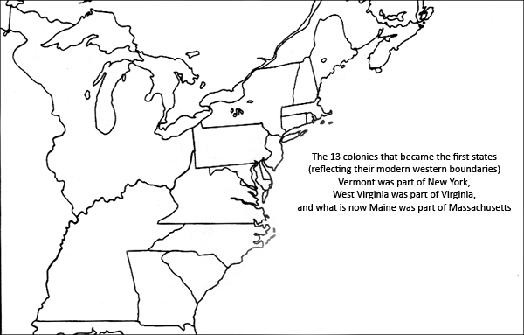
Also, add the Fall Line, or the Proclamation Line, as established by the Proclamation of 1763.

