French & Indian War Maps

Pre-war map: Indicate which countries owned which areas of North America before the French and Indian War.

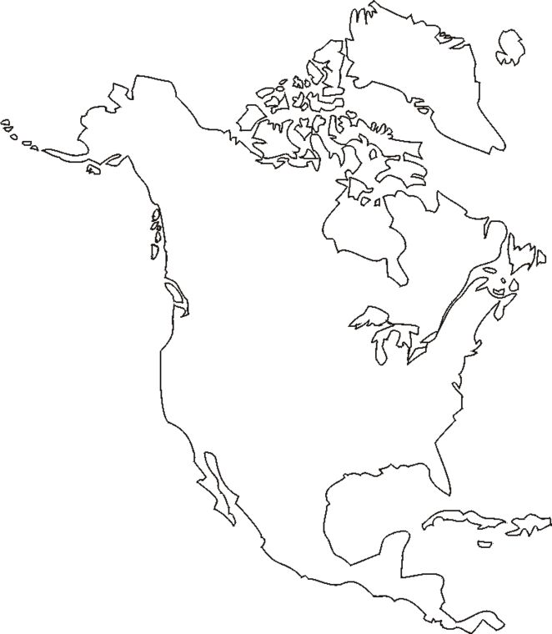

Post-war map: Indicate which countries owned which areas of North America after the French and Indian War.

