CW3.4.1 – Civil War Battle Stations
Fort Sumter (April 12, 1861)
Fort Sumter was a federal fort in Charleston Harbor, South Carolina, that needed additional supplies in April of 1861. This fort was important because it was one of two Union-controlled forts in southern territory. President Lincoln was faced with a difficult choice in April 1861. Sending a gunship to resupply the fort could be seen as an attack against the Confederacy. Not resupplying the fort could likely demonstrate weakness in the face of a rebellious south.
Lincoln decided to resupply the fort, and before his ship could get there, the Confederacy attacked. Thirty- three hours later, the fort fell to Confederate forces.
At Fort Sumter, the Confederacy was the aggressor. As a result of the South’s attack, thousands of northerners joined the Union army. Lincoln initially asked for 75,000 troops. By 1862, more than 700,000 men had signed up to fight.
Civil War Lesson #3: Battles of the War Copyright © 2011, The Regents of the University of California, All Rights Reserved
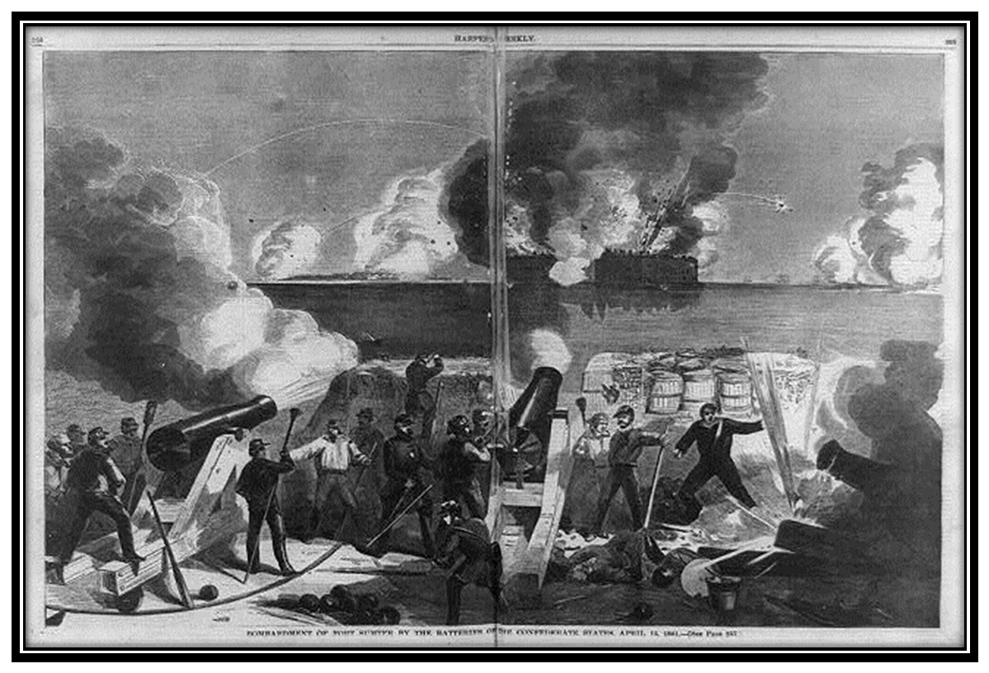
Bombardment of Fort Sumter by the Batteries of the Confederate Forces. Harpers’ Weekly, April 27, 1861. Source: The Library of Congress, http://www.loc.gov/pictures/item/96524550/
-

CW3.4.2 – Civil War Battle Stations
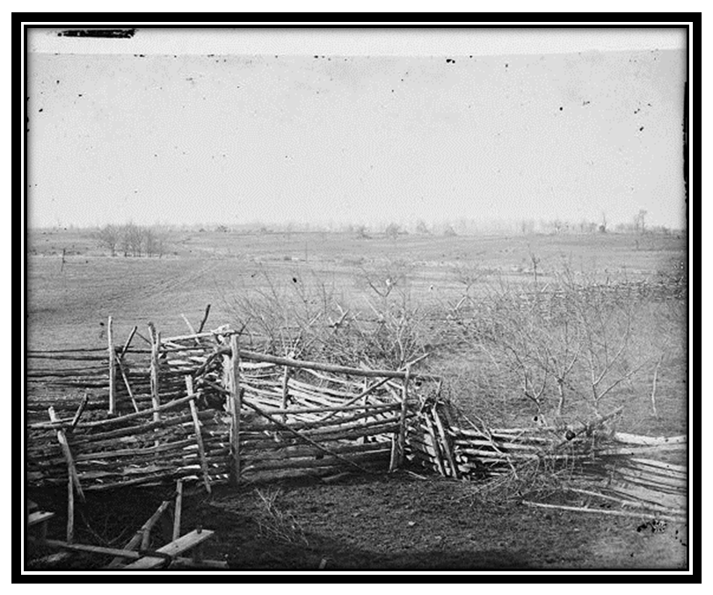
Bull Run / Manassas (July, 1861)
Bull Run, Virginia, view of the battlefield, July, 1861. Source: Library of Congress,http://www.loc.gov/pictures/item/cwp2003000005/PP/

Beauregard had two important advantages at Manassas. First, his spies in Washington learned that McDowell was preparing to attack. Second, McDowell’s inexperienced troops moved slowly in their attack, giving Beauregard significant time to prepare.
Early in the fight, Union troops pushed the South back. These initial victories were cheered on by hundreds of spectators who had travelled to Manassas from Washington. These spectators included reporters and members of the government, as well as average citizens.
As the battle wore on, however, the Confederacy turned the tide. Later the Confederate General Thomas J. Jackson became known as “Stonewall Jackson,” because his men believed he stood “like a stone wall” at the head of his troops in the face of Union attack.
During a critical moment in the fighting, two Union artillery batteries suddenly stopped firing. The batteries mistakenly believed that a regiment dressed in blue uniforms was a Union reinforcement regiment. Stonewall Jackson’s Virginians took advantage of this confusion and ordered a counterattack. This counterattack was the
Early in the war, President Lincoln called for an attack on western Virginia. He believed that an attack at Manassas, so close to Richmond, would discourage secessionists and severely hurt the Confederate ability to fight.
In July 1861, Union General Irwin McDowell led 35,000 troops out of Washington, DC. Irwin divided his troops into two parts: 15,000 were sent to fight 11,000 Confederate troops at Harper’s Ferry, leaving 20,000 Union troops to attack 20,000 Confederate troops at Manassas. This would have been a good plan if McDowell’s troops were experienced, but they weren’t.
The Confederate commander at Manassas was P.T. Beauregard, who had gained fame from his leadership at Fort Sumter.
The first time Union troops reported hearing an eerie scream coming from the Confederate line. This scream later became known as the “rebel yell.”
Union troops began to retreat and as panic set in, fled back across the Bull Run River towards Washington. Mysteriously, the Confederate troops did not follow and allowed many to fight another day.
The Battle of Bull Run, as the North called it, or Manassas, as the South called it,* was a major victory for the Confederacy, as it kept the Union from going after Richmond, the capital of the Confederacy, for close to a year. It was also a psychological victory for the South, as it inspired their confidence and made clear to the Union that victory over the Confederacy would neither be quick or easy.
*The Union often named their battles after nearby rivers. The Confederacy often named their battles after nearby towns or major roads.
CW3.4.3 – Civil War Battle Stations
U.S.S. Monitor vs. C.S.S. Virginia (formerly U.S.S. Merrimack) (March 9, 1862)
Before the Civil War, warships were made of wood, which bombs could split and fires could easily destroy. In June 1861, the Secretary of the Confederate Navy, Stephen D. Mallory (a former US Senator from Florida who had built the Confederate Navy from scratch [nothing]), authorized [ordered] the rebuilding of a damaged Union ship, the U.S.S. Merrimack. Renamed the C.S.S. Virginia, the first ironclad ship in the Confederate fleet was covered in two inches of metal and featured [had] ten guns and an iron ram at its prow [front].
The Union Navy was also experimenting with ironclad ships. The first ironclad ship in the Union fleet was the U.S.S. Monitor, which was launched in January
of 1862. The Monitor’s innovative [new] design included a flat deck, more than four inches of armor covering its propeller, the anchor, and all important machinery. The Monitor also had a revolving turret, or structure, mounted on its deck that housed [had inside] two eleven-inch guns, all covered in in eight inches of armor.
By April of 1862, all Confederate ports were in the hands of Union troops, with the exception of Charleston and Wilmington, North Carolina. To fight back against the Union’s domination [control of the ports], the Confederacy sent the C.S.S. Virginia on the attack. It was very successful at first, sinking five ships.
The Union sent the Monitor to fight back, and the two ironclad ships met in battle on March 9, off the coast of Virginia. It was an arduous [hard] battle that neither ship won.
Although both ships were eventually destroyed in later battles, this event marked the end of wooden naval vessels [ships].
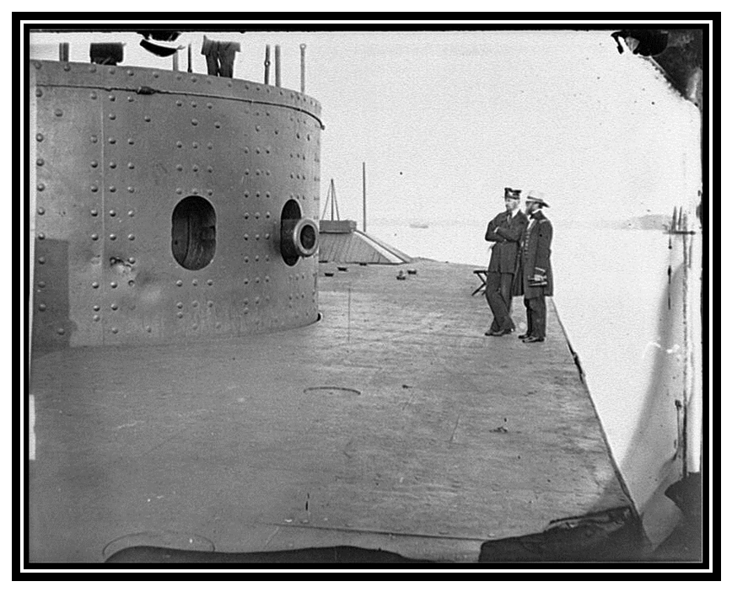
James River, Virginia, Deck and turret of U.S.S. Monitor, July 9, 1862. Source: Library of Congress,
http://www.loc.gov/pictures/item/cwp2003000713/PP/
-
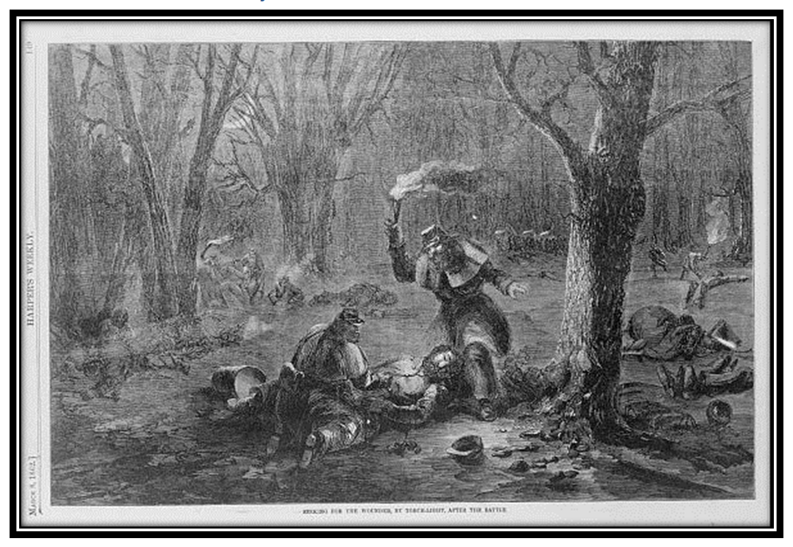
CW3.4.4 – Civil War Battle Stations
Fort Donelson (February, 1862)
Seeking for the wounded, by torch-light, after the battle. Print shows soldiers searching by torch-light through a wooded area for wounded soldiers after a Rebel assault on Schwartz's battery during the Union siege of Fort Donelson, Tennessee. Harpers’ Weekly, March 8, 1862. Source: The Library of Congress, http://www.loc.gov/pictures/item/2004669212/
The 13,000 Confederates surrendered, and Grant became a hero in the north. After this victory, Grant had more success in the west, and later captured the first Confederate capital at Nashville.
Page 19
Civil War Lesson #3: Battles of the War Copyright © 2011, The Regents of the University of California, All Rights Reserved
Coming off a recent victory at nearby Fort Henry, Union General Ulysses S. Grant surrounded the Confederate forces hunkered down [staying] at Fort Donelson along the Cumberland River in Tennessee. Although the Confederate forces nearly escaped in a daring breakout, Grant and his troops were able to counterattack [attacking against an attack] to gain the upper hand. By the end of the day, almost 1,000 men had died and 3,000 more were wounded and lay suffering on the freezing ground outside the fort. During the night, a number of Confederate commanders, including the infamous Nathan Bedford Forrest, who would later prove to be a thorn in Grant’s side, escaped. In the morning of February 16, the Confederate general asked for terms of surrender. Grant’s response: unconditional surrender or face an incoming attack.
Following the Fort Donelson victory, the Union was overconfident and thus surprised when they were attacked at the woods near Shiloh in southwestern Tennessee. Union General William Tecumseh Sherman remarked, “My God, we’re attacked,” after his orderly [servant soldier] was unexpectedly [by surprise] killed.

CW3.4.5 – Civil War Battle Stations
Shiloh (April 6, 1862)
Sherman recovered, however, and for the next twelve hours, his leadership was as one historian wrote, “cool and courageous.” Leading from the front of his troops, Sherman was wounded, and had three horses shot out from underneath him.
Despite the heavy losses the Union sustained [had] in the first day of surprise battle, Grant counterattacked [attacked the attackers] the next day, sending his 40,000 troops to battle against P.T. Beauregard’s 25,000 soldiers. Later in the day, Grant’s troops were reinforced [made stronger] with additional [more] troops. By the afternoon, the Confederacy was in retreat. The Union did not follow as the casualties [dead and wounded soldiers] from the battle were overwhelming [too much].
The Battle of Shiloh was the bloodiest battle of the war thus far. More than 20,000 soldiers died or were wounded. Some historians argue that this battle was the beginning of “total war” for both the Union and the Confederacy. It also marked the end of Southern control of the Mississippi Valley.
The battle of Pittsburgh, Tenn. April 7th, 1862. General Ulysses S. Grant leading a charge on the Rebels at Pittsburgh, Tennessee. Currier and Ives. Source: Library of Congress, http://www.loc.gov/pictures/item/90709391/
-
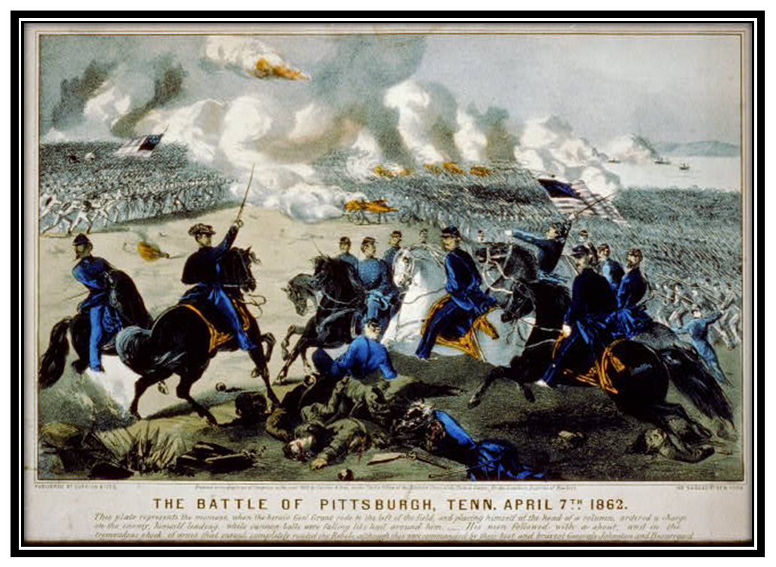

CW3.4.6 – Civil War Battle Stations
Shenandoah (May, 1862)
Confederate General Stonewall Jackson led 17,000 men through a series of battles in the Shenandoah Valley. Jackson’s troops benefitted from their knowledge of the geography of the Valley, outmaneuvering [hiding and escaping from] more than 30,000 Union troops who were chasing them.
Shenandoah was significant [important] because it kept the pressure off the Confederate capital, Richmond. It also resulted in the capture of more than 2,000 Union prisoners and 10,000 rifles for the Confederate cause.
The war in the Shenandoah Valley - burning the bridge near Mount Jackson, by order of the Rebel General / from a sketch by our special artist, Mr. Edwin Forbes. Print shows Confederate troops, under the command of General Stonewall Jackson, burning the bridge over the north fork of the Shenandoah River, June 4, 1862. Source: Library of Congress, http://www.loc.gov/pictures/item/2003668326/
Civil War Lesson #3: Battles of the War Copyright © 2011, The Regents of the University of California, All Rights Reserved
-
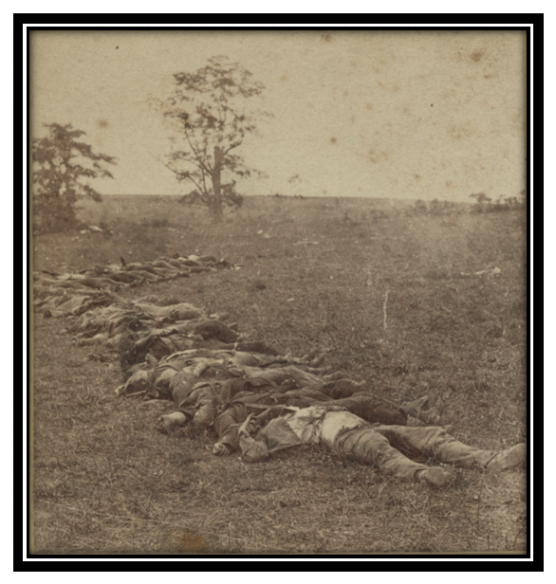

CW3.4.7 – Civil War Battle Stations
Antietam (September, 1862)
Gathered together for burial after the Battle of Antietam. C. 1862. Photographer: Alexander Gardner. Source: Library of Congress: http://www.loc.gov/pictures/item/2011648595/.
were wounded. Lee fled with only 30,000 troops, and the Union army did not go after him, probably because of the devastation [destruction] they had seen the day before. Union General McClellan had won a strategic victory at Antietam, but had yet again wasted an opportunity to destroy the Confederate forces once and for all.
Following another loss at Bull Run in August of 1862, Union forces were on the run, not far from the capital of Washington, DC. The Confederate President Jefferson Davis, and Military General, Robert E. Lee, saw an opportunity to continue their victories by marching to Maryland. Lee crossed the Potomac River with 55,000 men and hoped that the people of Maryland would rise up in support of the Confederate cause. Unfortunately for Lee, there was no popular uprising (revolt.) He next divided up his troops in order to capture a Union military post.
On September 13 in a field near Frederick, Maryland, two Union troops found a copy of Lee’s orders to divide his troops into four parts wrapped around three cigars. Union General McClellan did not move quickly to act upon this advantage, however. He waited almost eighteen hours to begin to move his troops to attack Lee. Lee used this time to reorganize, having learned from a Maryland citizen about the Union’s discovery of his orders.
On September 17, the two forces finally met at Antietam Creek, near Sharpsburg. By the time they fought, the armies were relatively well-matched. The southerners were on the defense and the Union attacked. The fighting was horrible; by the end of the day, 6,000 troops had died, and 17,000 more

CW3.4.8 – Civil War Battle Stations
Gettysburg (July 3, 1863)
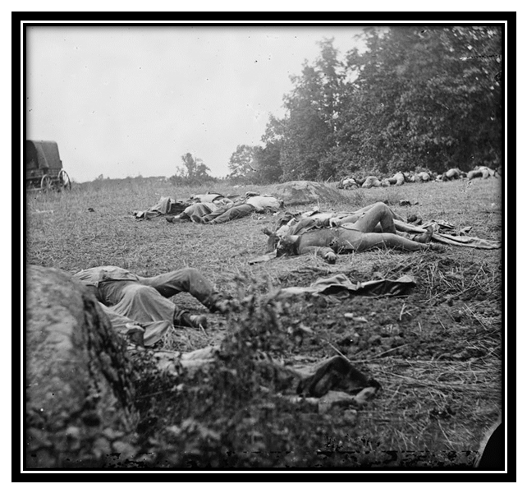
Gettysburg, Pa. Confederate dead gathered for burial at the edge of the woods, and demoralize [discourage] the Union by defeat in their own territory. At the same time, President Lincoln directed his latest General, George Gordon Meade, to find and destroy Lee’s army.
As the Confederate troops marched north, a division [a group of 17,000 to 21,000 soldiers commanded by General A.P. Hill heard that there was a supply of shoes in Gettysburg, Pennsylvania. When they arrived, they did find shoes, as well as two Union brigades [a group of 2,500 to 4,000 soldiers] under the leadership of John Buford. Buford quickly sent for reinforcements [more troops], as he had fewer men and weapons than the Confederate division. For two hours, Buford’s troops held off the larger southern force, until they were reinforced by men from John Reynolds’ tough brigade. By the afternoon of July 1, there were 24,000 Confederate soldiers fighting 20,000 Union troops. Reinforcements continued to arrive from both the Northern and Southern armies.
The battle was at first a stalemate [tie], since the Confederacy had In May 1863, the Union suffered [had] an important loss at Chancellorsville. The Confederacy, under the leadership of Robert E. Lee and Stonewall Jackson, defeated a larger Union force in a bloody and horrific battle. The Confederacy lost 13,000 men at Chancellorsville, including Stonewall Jackson, and the Union lost 11,000. The South’s win at Chancellorsville likely led to overconfidence among the Confederates – they believed that they couldn’t lose.
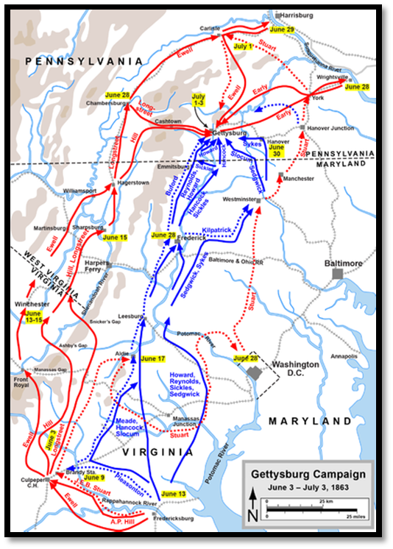
Confederate General Robert E. Lee then directed [led] his troops north, in order to take advantage of the momentum [progress] they’d built from Chancellorsville. He brought together 75,000 men who were well-fed and had high morale. Lee planned to follow Grant’s practice of living off the land.
Lee had more men, but the Union had the better position – the high ground from which they could defend and not have to attack. Lee’s trusted subordinate, General Longstreet, argued that the higher ground advantage was simply too much for the Confederate troops to overcome, but Lee continued on and even put Longstreet in charge of attacking Cemetery Ridge. Although they suffered horrendous [terrible] losses, the Union troops continued to use the high ground, pushing back Confederate attacks at the two Round Top hills. Of particular note was the courage of the 20th Maine regiment, commanded by a former professor at Bowdoin College, Joshua Chamberlain. After one-third of his troops were killed, Chamberlain found himself without any ammunition. Instead of surrendering, Chamberlain ordered his troops to fix bayonets and charge against the advancing Confederate troops, who were overwhelmed by Chamberlain and his men, maintaining Union control of Little Round Top.
On July 3rd, 15,000 Confederate troops launched a massive attack across open ground toward the Union defenses. It was a courageous and ultimately doomed effort, as the Union’s territorial advantage [holding the high ground] made the southerners easy targets. Almost half of the southern force was killed in this advance and retreat.
Lee took the loss hard, blaming himself and offering his resignation to the Confederate President Jefferson Davis (Davis refused to accept it). George Meade continued the Union tradition of not taking advantage of southern retreat. What was left of the Confederate forces retreated south without chase from Union troops.
More than 23,000 Union troops died at Gettysburg. The South lost 28,000 men, more than a third of Lee’s army. In addition, the South lost the confidence they had gained at Chancellorsville. Gettysburg, along with Vicksburg, is often seen as the turning point of the war – the beginning of the end for the South.
Civil War Lesson #3: Battles of the War Copyright © 2011, The Regents of the University of California, All Rights Reserved
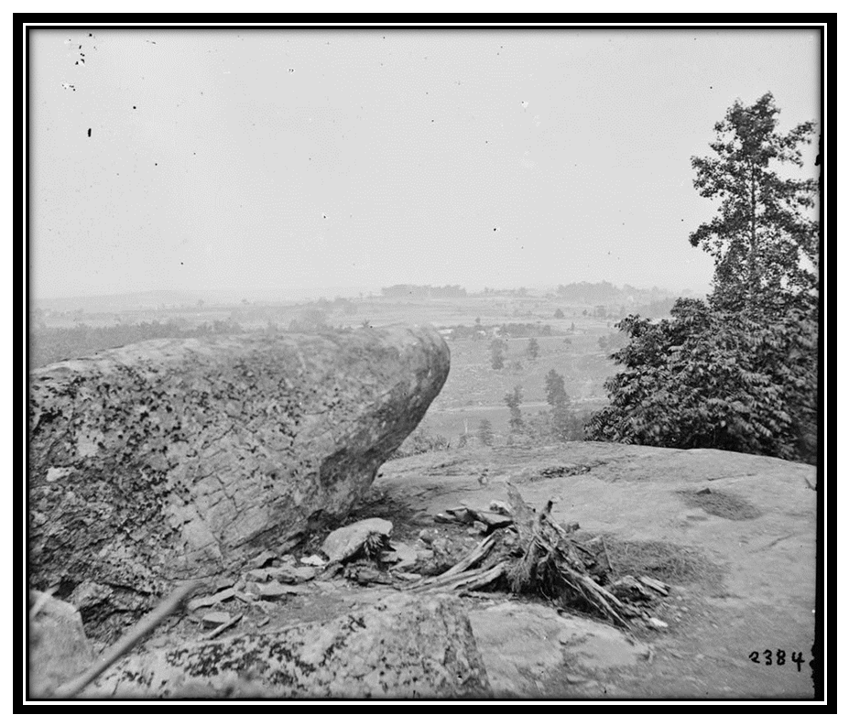
Gettysburg, Pa. The center of the Federal position viewed from Little Round Top. 1863.
Source: Library of Congresshttp://www.loc.gov/pictures/item/cwp2003000195/PP/.
-

CW3.4.9 – Civil War Battle Stations
Vicksburg (July 4, 1863)
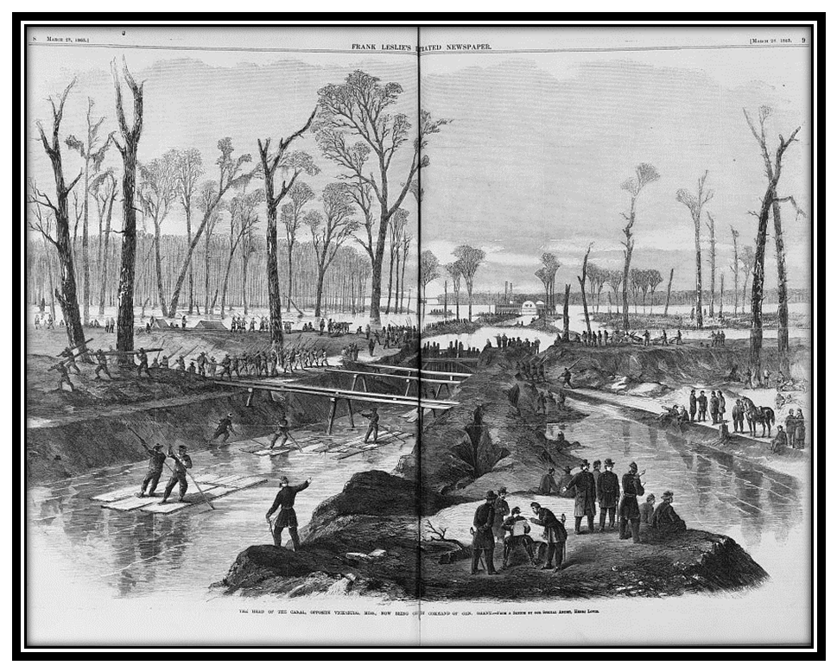
The head of the canal, opposite Vicksburg, Miss., now being cut by Command of Gen. Grant / from a sketch by our special artist, Henri Lovie. Print shows Union troops and contrabands constructing a canal near Vicksburg,
Mississippi., March 1863. Source: Library of Congress, http://www.loc.gov/pictures/item/2003668335/
These losses did not sit well with Grant [he didn’t like to lose], so in the spring of 1863, he returned to Mississippi and launched a campaign that would cement [build] his reputation as a feared military leader. First, he marched his men along the Mississippi to a point below Vicksburg. Union gunboats then joined in the plan, sailing down the river in front of the fortified city. On April 30th, his troops crossed the river, near the entrance to the city. Instead of heading north into Vicksburg, Grant then directed his troops east to Jackson, Mississippi, which fell on May 14. Next, Grant and General Sherman took out smaller confederate forces at Champion’s Hill and Black River, leaving Vicksburg the remaining target.
In the late fall and early winter of 1862, Union General U.S. Grant unsuccessfully campaigned [fought battles] for control of Mississippi, and, in particular, for the capture of Vicksburg, Mississippi. Grant’s efforts were hampered [made more difficult] by Confederate leader Nathan Bedford Forrest, whose cavalry first raided, and then escaped from, Union troops multiple times. In late December, Grant called off his campaign and began to retreat to Tennessee. On his way back, his troops, who did not have access to Union supply lines, were forced to “live off the land,” securing food and supplies however they could from the local countryside during their retreat.
For the next eighteen days, Grant’s troops marched 180 miles, winning five battles and destroying the troops guarding Vicksburg. He then launched a major attack on the city itself, which was pushed back. Finally, Grant ordered a siege of the city – preventing anyone from going in or out and continually launching artillery into the city itself. The people of Vicksburg suffered terribly for six weeks, hoping to hold out for Confederate reinforcements that never came. People were starving, dying of disease and injury. On Independence Day, July 4, 1863, Vicksburg surrendered.
The battle was a major victory for the Union, demonstrated the North’s ability to fight without access to supplies, and meant that Mississippi River was now in Union hands.

CW6.4.10 – Civil War Battle Stations
Fort Wagner (July 18, 1863)
On July 18, 1863, two Union brigades [a group of 2,500 to 4,000 soldiers] attacked Fort Wagner, on Charleston harbor. The attack was led by Colonel Robert Gould Shaw, the son of leading abolitionists from Boston. Shaw commanded the 54th Massachusetts Regiment, an African-American regiment [a group of 3,000 to 5,000 soldiers], whose story was the basis for the film Glory.

The Union lost this battle when the Confederacy repulsed [fought off] the Union attack against the fort. Shaw died in battle, along with almost half of his troops. However, the battle affected public opinion in the North, with more citizens recognizing the contributions of African-American soldiers, the cause of abolition, and the
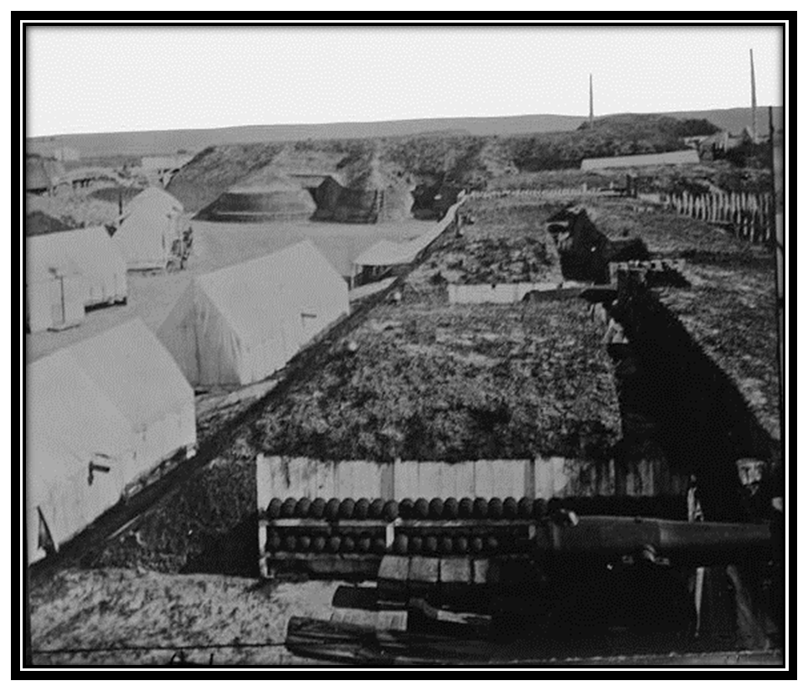
-

CW3.4.11 – Civil War Battle Stations
Sherman’s March to the Sea (November - December, 1864)
On November 15th, 1864, Union General William Tecumseh Sherman’s troops set fire to Atlanta. Next, Sherman set out with 60,000 troops for Savannah, Georgia’s best sea port. Along the way, Sherman’s men looted the countryside, taking or destroying everything of potential value as they travelled to the sea. They tore up railroad tracks, vandalized homes, and destroyed farms.
After taking Savannah, Sherman continued to pillage [loot] the South, moving next to South Carolina. Union troops burned the city of Columbia, South Carolina, to the ground.
Sherman’s tactics, which are often referred to as “total war,” were designed to break the spirit of the Confederacy – to take the war to the average southerner in the hopes that they would no longer be willing to fight.
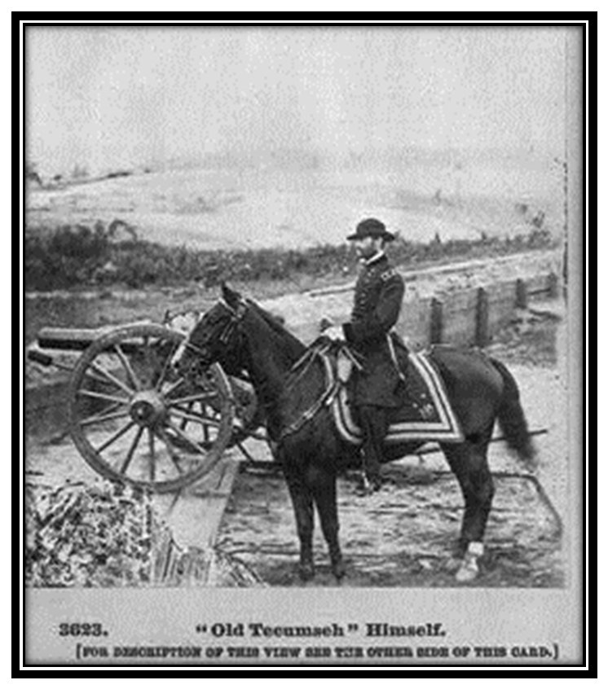
"Old Tecumseh" Himself. Portrait of William Tecumseh Sherman. Photographer:
George Barnard. Source: Library of Congress:
http://www.loc.gov/pictures/item/2003653366/

CW3.4.12 – Civil War Battle Stations
Appomattox Courthouse (April 9, 1865)
By April 9. 1865, Robert E. Lee only had 35,000 troops left to fight the Union’s 120,000 soldiers. The Confederate forces were tired, hungry, and demoralized. One week earlier, Abraham Lincoln and U.S. Grant had walked through the streets of the captured Confederate capital, Richmond. On the 9th, Lee and his troops tried to escape from Union forces near Appomattox Courthouse, but were not able to do so.
Lee surrendered to Grant at the home of Wilmer McLain, a former resident of Manassas, who had moved his family to Appomattox after the first battle of the war, Bull Run, came to close to his home. Grant agreed to let Lee and his men go home, in return for their surrender. These soldiers would not, as many Confederates feared, be tried for treason. They also were allowed to keep their horses.

