AP COGO
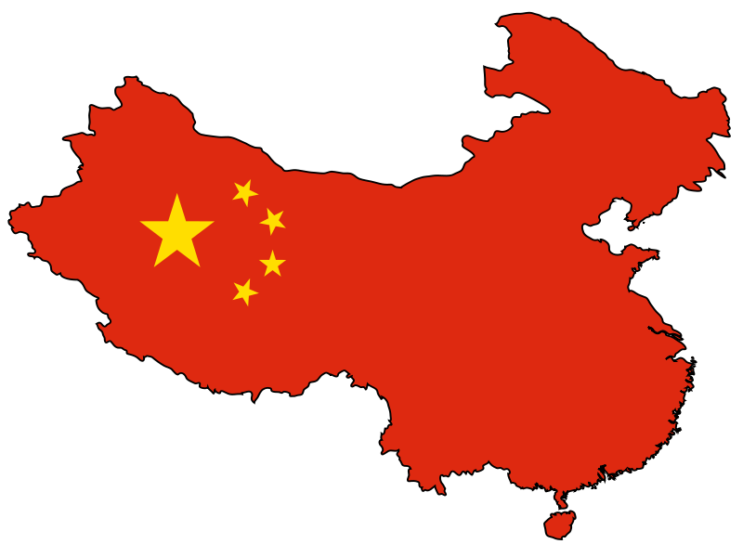
China

China Mini-Presentation Topics

Directions: You and your partners should choose ONE of the following topics to research and present to the class during the course of this unit. Prepare a brief (3 - 5 minute) presentation. Limit your text to key points and provide pictures/graphics to enhance your presentation. You may use Powerpoint, Prezi, or any other presentation software. All presentations should be sent to Mrs. Lacks before class on the date of your presentation.

TOPICS:

- China’s Relations/Policies toward Hong Kong
  - Historic/Current

- China’s Relations/Policies toward Taiwan
  - Historic/Current

- China’s Relations/Policies toward Tibet
  - Historic/Current

- China’s Communist Party General Secretary/President of China Xi Jinping
  - Background and expected policies/vision for China

- China’s Judicial/Legal System
  - Include burden of proof, conviction rate, death penalty crimes

- The Role of Women in Chinese Society and Politics
  - How has communism shaped the role of women in society/politics?

- China’s Relations/Policies Toward Ethnic Groups
  - Identify major ethnic groups/current policy

- China’s Relations/Policies toward Falun Gong
  - Explain what Falun Gong is and why China has reacted negatively to it

- China’s Population Challenges
  - One-child policy (reason for policy, enforcement, current status), rural/urban population shift, aging population

