US Government
14th Amendment Activity

Cite examples of legislation (court cases, acts, amendments, etc.) passed in the US to promote equality among residents.

Group | Legislation, court cases, etc. (+explanation)
Women

Hispanics/Latinos

Asian Americans

Native Americans

Ability & Age

Sexual orientation

Immigrants

What is the process to become a U.S. citizen? In what ways is this goal attainable for many immigrants today? In what ways is it difficult?

US Citizenship & Naturalization Service: https://www.uscis.gov/sites/default/files/USCIS/files/M-1051.pdf

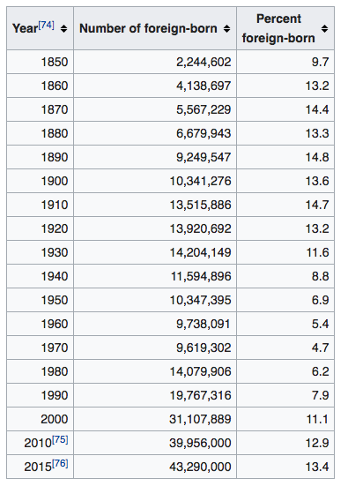

Compare and contrast current immigration data to data from an earlier time. Is the total number of immigrants similar or different from today? Is the percentage of immigrants greater or less than today. How do the data compare?

